AGLatency Tool User Manual



10/16/2018

Version Draft

**Prepared by**

**Kevin Barlett**

Premier Field Engineer – Data and AI

Kevin.Barlett@microsoft.com

Table of Contents

1 Summary 4

2 Prerequisites 5

2.1 .Net version 5

3 Download and install 6

3.1 Download 6

3.2 Install 6

4 Generate AG topology XML files 8

4.1 Execute environment and topology query 8

5 Create Extended Event trace 12

5.1 Execute Extended Event trace script 12

6 Load XEvent trace files 16

6.1 Copy trace files to client machine 16

7 Report analysis 19

7.1 Reference chart 19

7.2 Main screen 20

7.3 Primary Statistics section 23

7.4 Secondary Statistics section 30

8 Miscellaneous 37

8.1 Historical reports 37

9 References 38

MICROSOFT MAKES NO WARRANTIES, EXPRESS OR IMPLIED, IN THIS DOCUMENT.

Complying with all applicable copyright laws is the responsibility of the user.  Without limiting the rights under copyright, no part of this document may be reproduced, stored in or introduced into a retrieval system, or transmitted in any form or by any means (electronic, mechanical, photocopying, recording, or otherwise), or for any purpose, without the express written permission of Microsoft Corporation.

Microsoft may have patents, patent applications, trademarks, copyrights, or other intellectual property rights covering subject matter in this document.  Except as expressly provided in any written license agreement from Microsoft, our provision of this document does not give you any license to these patents, trademarks, copyrights, or other intellectual property.

The descriptions of other companies’ products in this document, if any, are provided only as a convenience to you.  Any such references should not be considered an endorsement or support by Microsoft.  Microsoft cannot guarantee their accuracy, and the products may change over time. Also, the descriptions are intended as brief highlights to aid understanding, rather than as thorough coverage. For authoritative descriptions of these products, please consult their respective manufacturers.

© 2018 Microsoft Corporation. All rights reserved. Any use or distribution of these materials without express authorization of Microsoft Corp. is strictly prohibited.

Microsoft and Windows are either registered trademarks or trademarks of Microsoft Corporation in the United States and/or other countries.

The names of actual companies and products mentioned herein may be the trademarks of their respective owners.

1. Summary

The purpose of this document is to detail the download, installation and use of the AG (Availability Group) Latency Tool. The AGLatency tool can be used to determine which step in a synchronous AlwaysOn Availability Group replication topology is generating the most latency.

1. Prerequisites

This section details the prerequisites for using the AGLatency Tool.



## .Net version

The AGLatency tool requires .Net version 4.5.2 or higher.

1. Download and install

The purpose of this section is to detail the process for downloading and installing the AGLatency Tool.



## Download

The AG Latency tool is available on GitHub at the link below.

<https://github.com/suyouquan/AGLatency/releases/download/v2.0/AGLatencyV2.0.zip>

The main project page is located at the link below.

<https://github.com/suyouquan/AGLatency>

## Install

1. Unzip the AGLatencyV2.0.zip file to a suitable location on the client machine.

**NOTE:** Best practice is to extract and install the AGLatency Tool on a client workstation or non-production server.

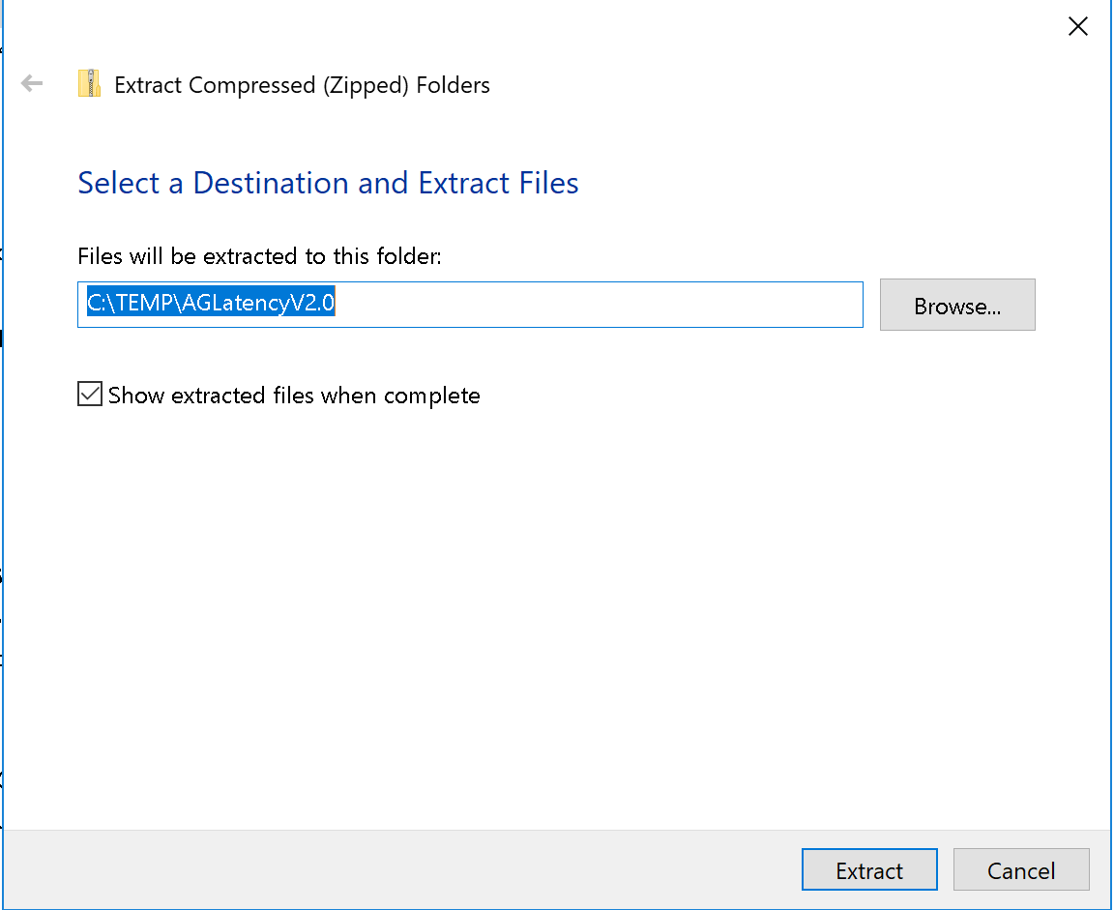

1. Double-click the AGLatency.exe file. The AGLatency Tool main screen will appear.

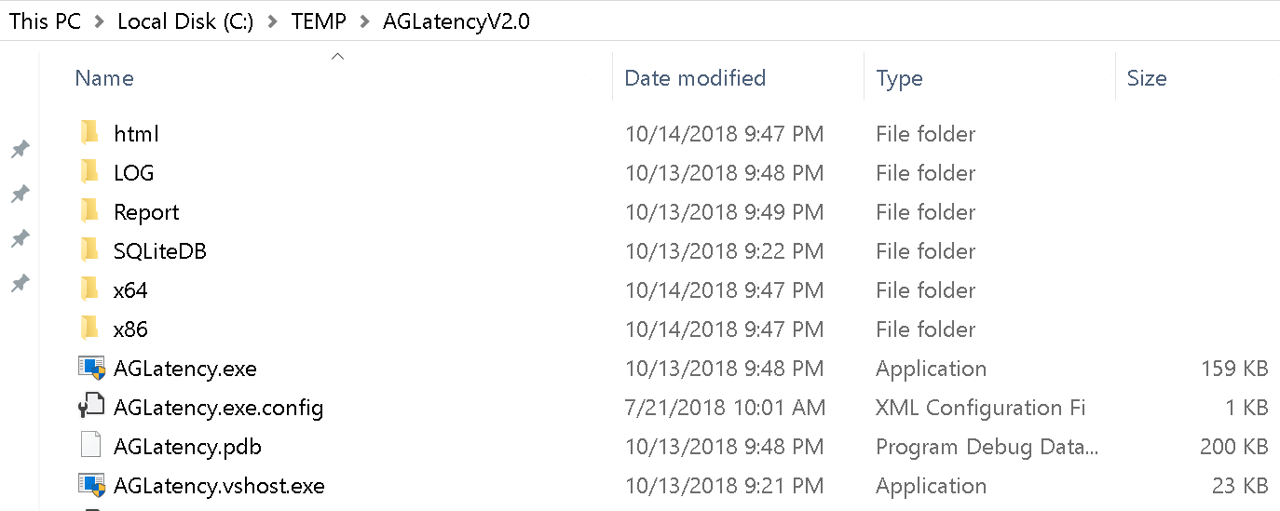

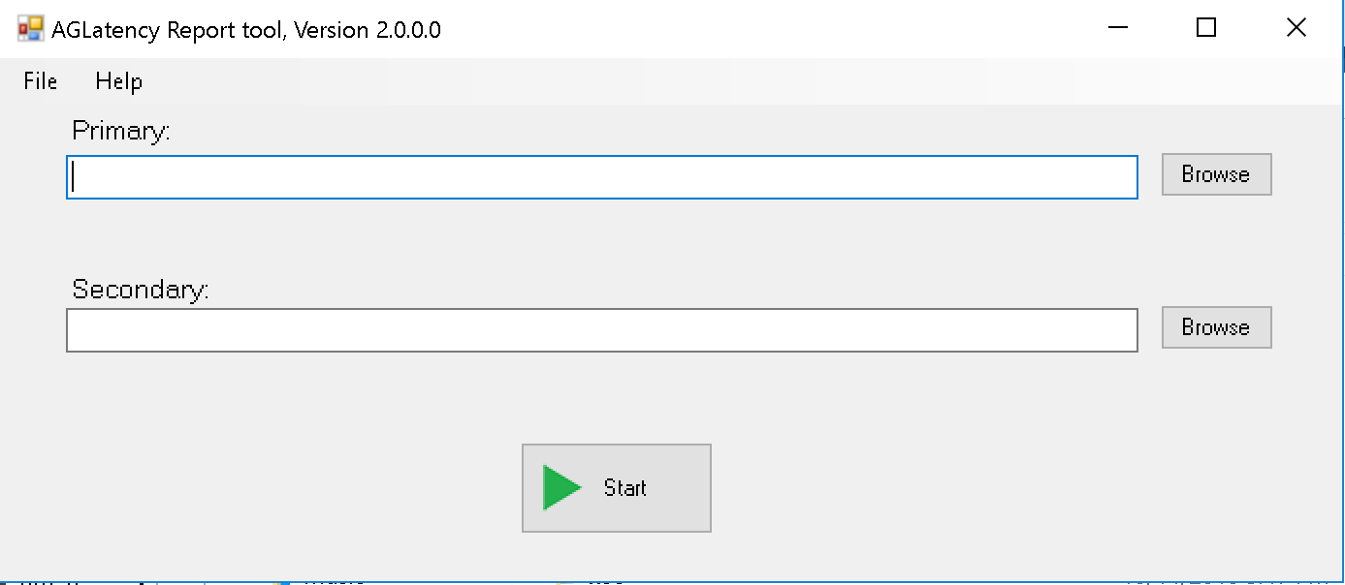

2. Generate AG topology XML files

This section details the process of generating XML query results containing the AlwaysOn Availability Group environment and topology information.



## Execute environment and topology query

1. Choose “File” 🡪 “TSQL Script”.

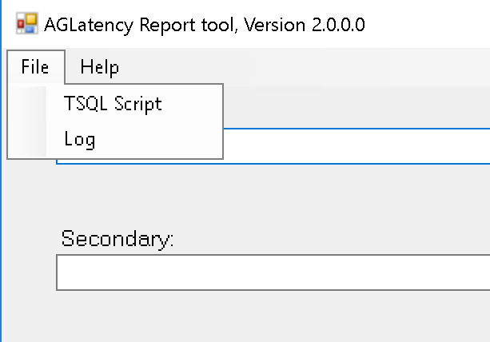

1. A text document will open. Choose the first query and execute on both the primary and secondary replicas.

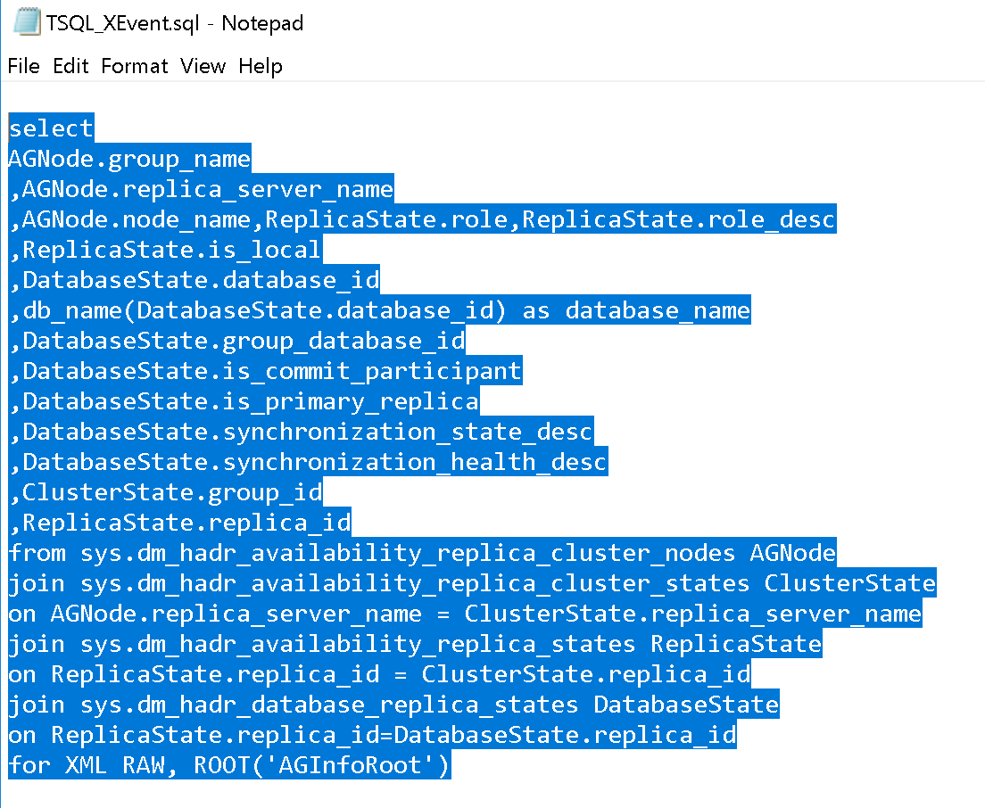

1. Save the XML query results from the primary and secondary replicas to separate files. Click the XML to open the results in a new SSMS tab.

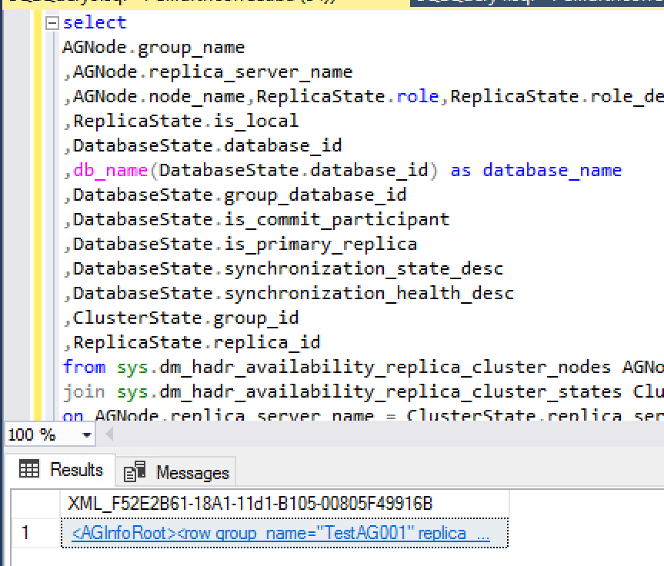



1. Save the XML contents of this tab to a file, keeping the results for the primary and secondary replicas in separate files. Separate directories for each replica are helpful in preventing confusion.

**NOTE:** The XML results files must be named PRIMARY.xml and SECONDARY.xml.

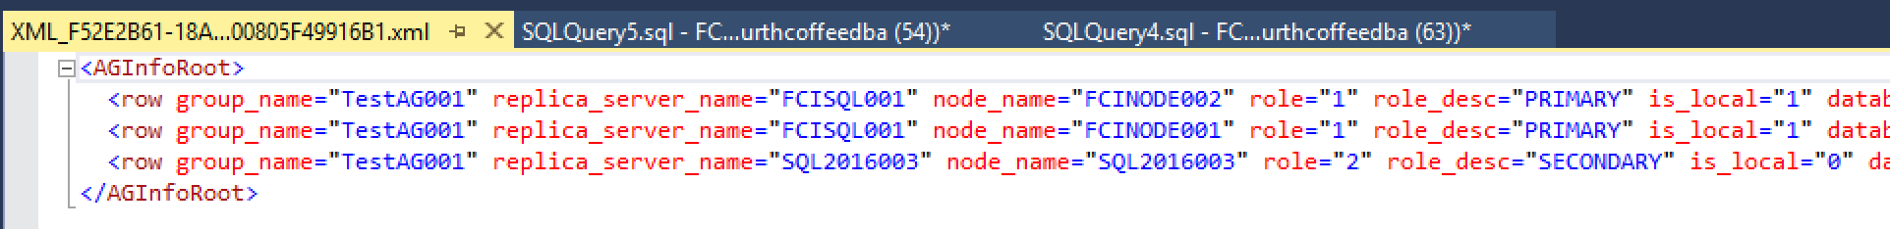

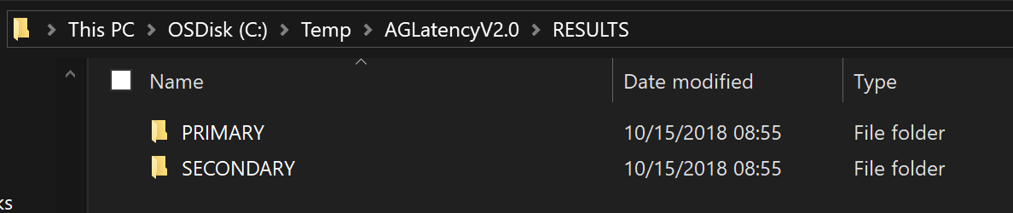

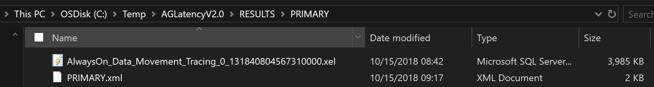

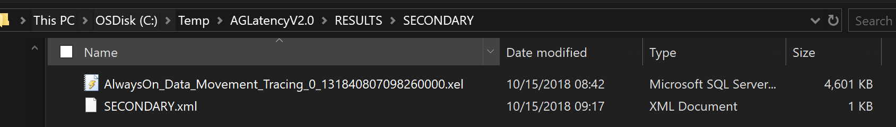

1. Create Extended Event trace

The purpose of this section is to describe the process for creating the Extended Events trace to collect the data the tool will use to perform its analysis.



## Execute Extended Event trace script

1. From the main screen of the AGLatency Tool, select “File” 🡪 “TSQL Script”. This will open a text document containing the extended event trace definition.



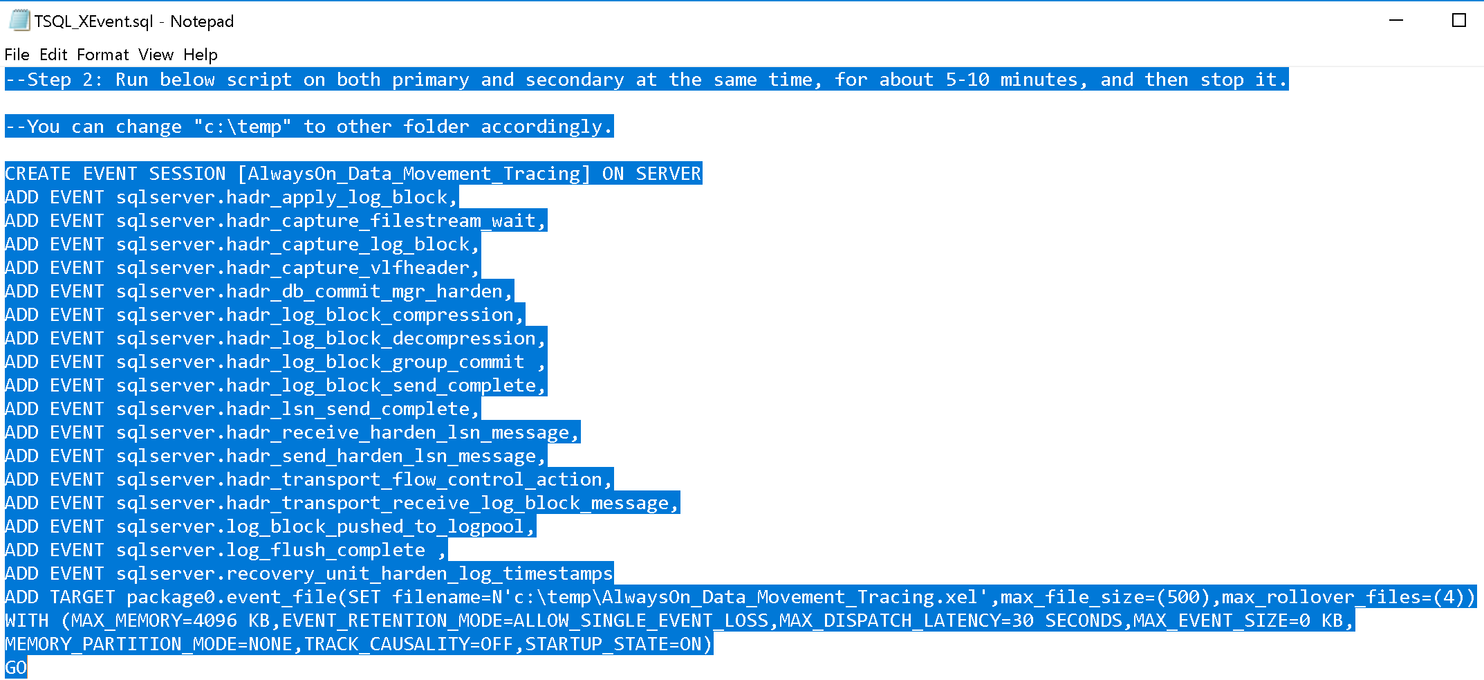

1. Modify the extended event target settings to adjust the location to which the trace files are written, the maximum size per trace file and the maximum number of trace files.

For instance, in the example below, extended event trace files will be written to “C:\Temp\AlwaysOn_Data_Movement_Tracing.xel”. Each file will have a maximum size of 500MB and four (4) trace files will be created.



1. Start the extended event trace using the SSMS GUI or TSQL command.

**TSQL:**

ALTER EVENT SESSION [AlwaysOn_Data_Movement_Tracing] ON SERVER STATE=START;

**SSMS:**

Expand the “Management” folder 🡪 “Extended Events” node 🡪 “Sessions” folder. Right-click the “AlwaysOn_Data_Movement_Tracing” session and choose “Start Session”

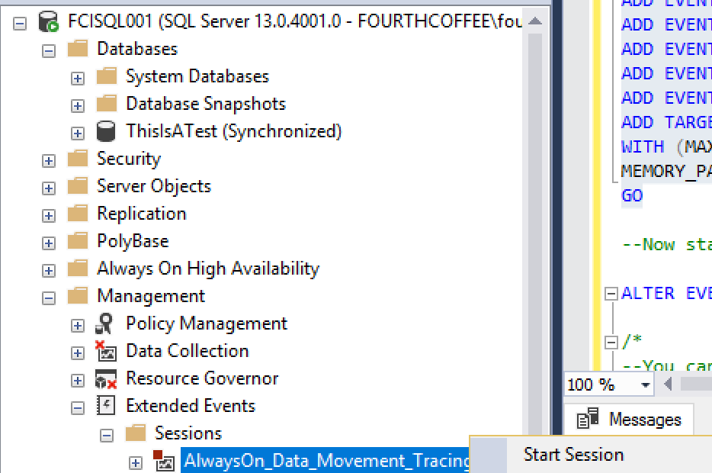

1. Once running, the extended event trace files should be visible at the specified filesystem location. Allow the trace session to collect data for 5 – 10 minutes.

**NOTE: On busy systems, these trace files have the potential to grow very rapidly and consume multi-GB of space!**

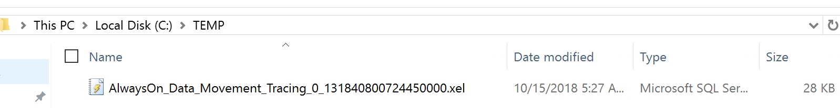

1. After approximately 10 minutes has elapsed, stop the extended event trace. This can be done through the SSMS GUI or via a TSQL command.

**TSQL:**

ALTER EVENT SESSION [AlwaysOn_Data_Movement_Tracing] ON SERVER STATE=STOP;

**SSMS:**

Expand the “Management” folder 🡪 “Extended Events” node 🡪 “Sessions” folder. Right-click the “AlwaysOn_Data_Movement_Tracing” session and choose “Stop Session”

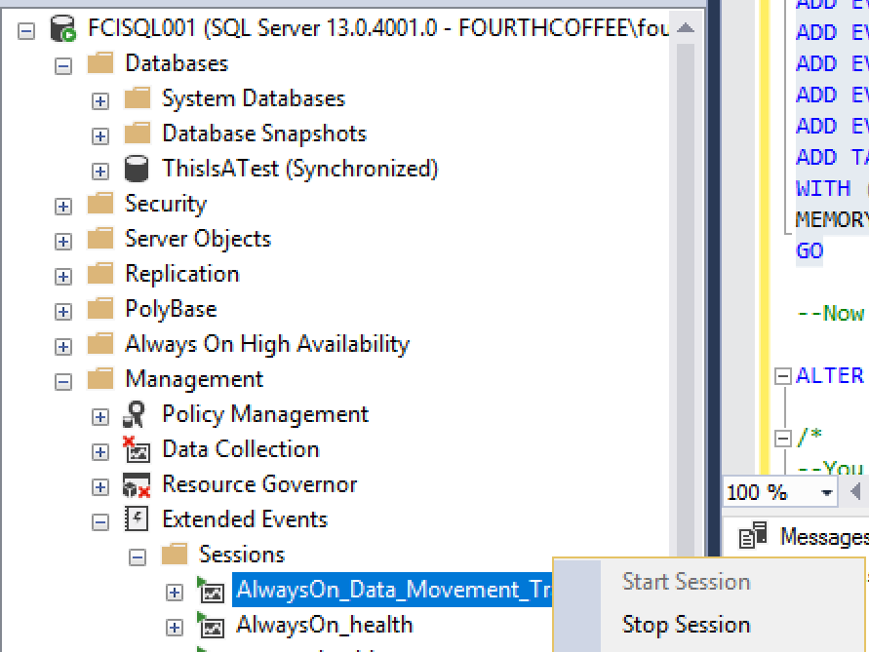

3. Load XEvent trace files

The purpose of this section is to detail the process of loading the extended event trace files into the AGLatency Tool for analysis.



## Copy trace files to client machine

1. Copy the extended event trace files from both the primary and secondary replicas to a location on the client machine from which the AGLatency Tool was opened. Separate directories for each replica are helpful in preventing confusion.



1. In the AGLatency Tool, browse to the location of the trace file for the primary replica. Repeat the same process for the secondary replica.

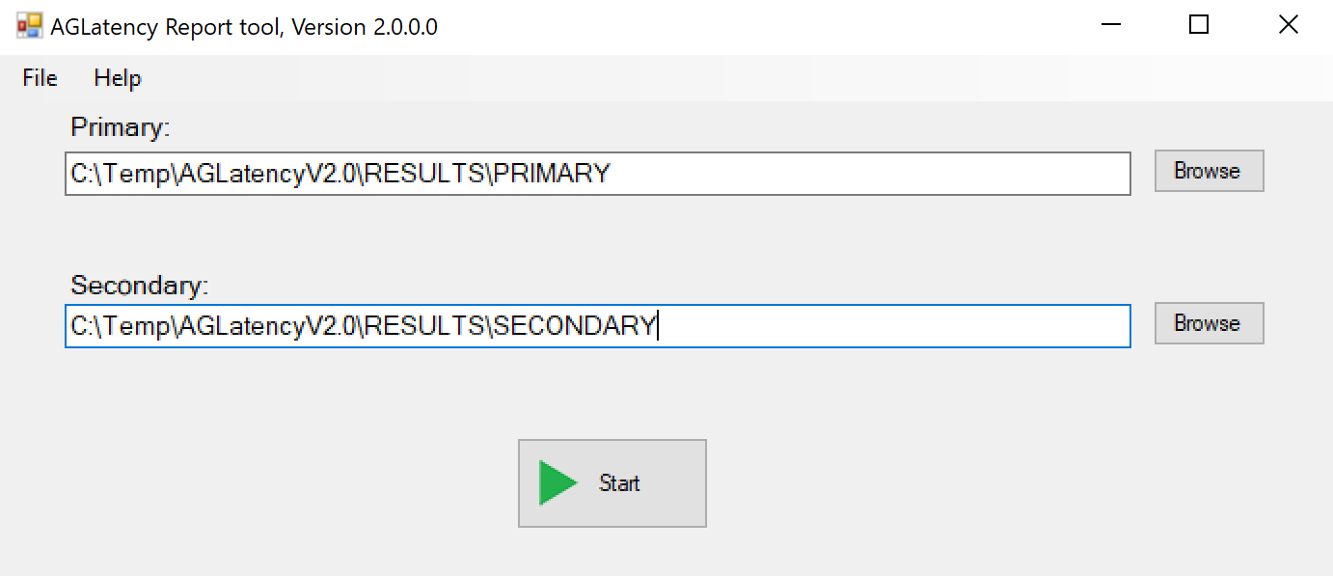

1. Press the “Start” button to begin the trace file analysis. Processing time is dependent upon the quantity and size of the extended event trace files.

**NOTE:** Before pressing “Start”, ensure both the environment and topology XML results AND the extended event trace files are present in the PRIMARY and SECONDARY locations specified below.





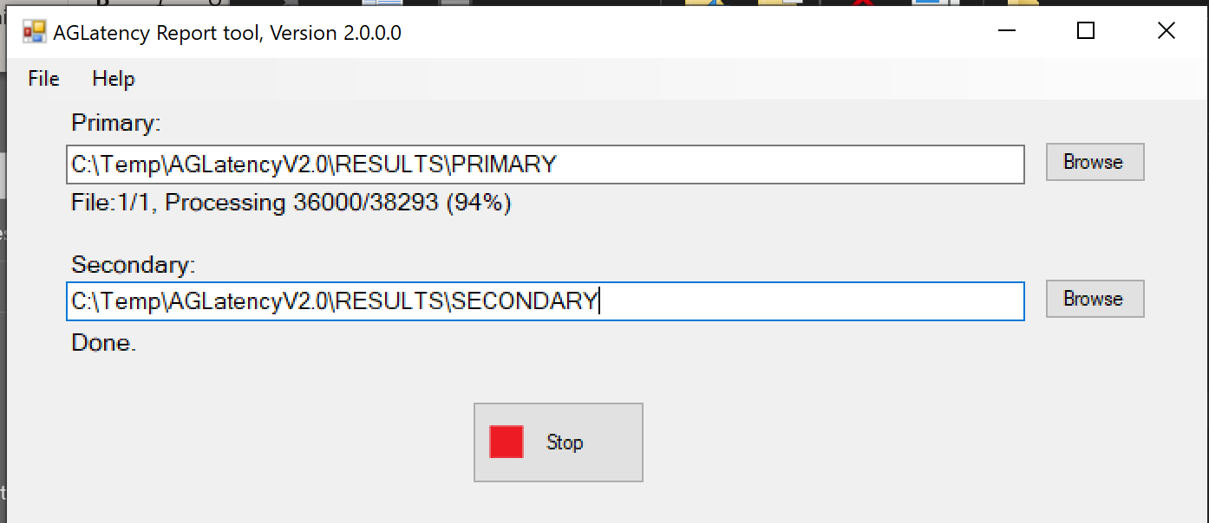

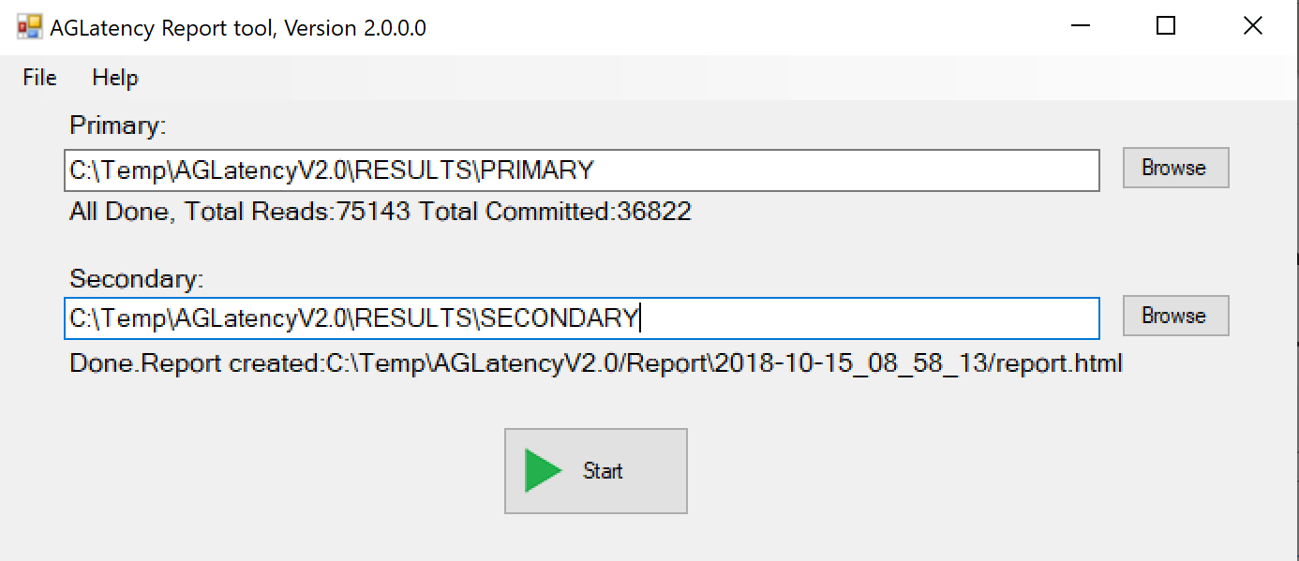

At the completion of the extended event trace file processing, an internet browser window will open indicating that the data is loading to main report.

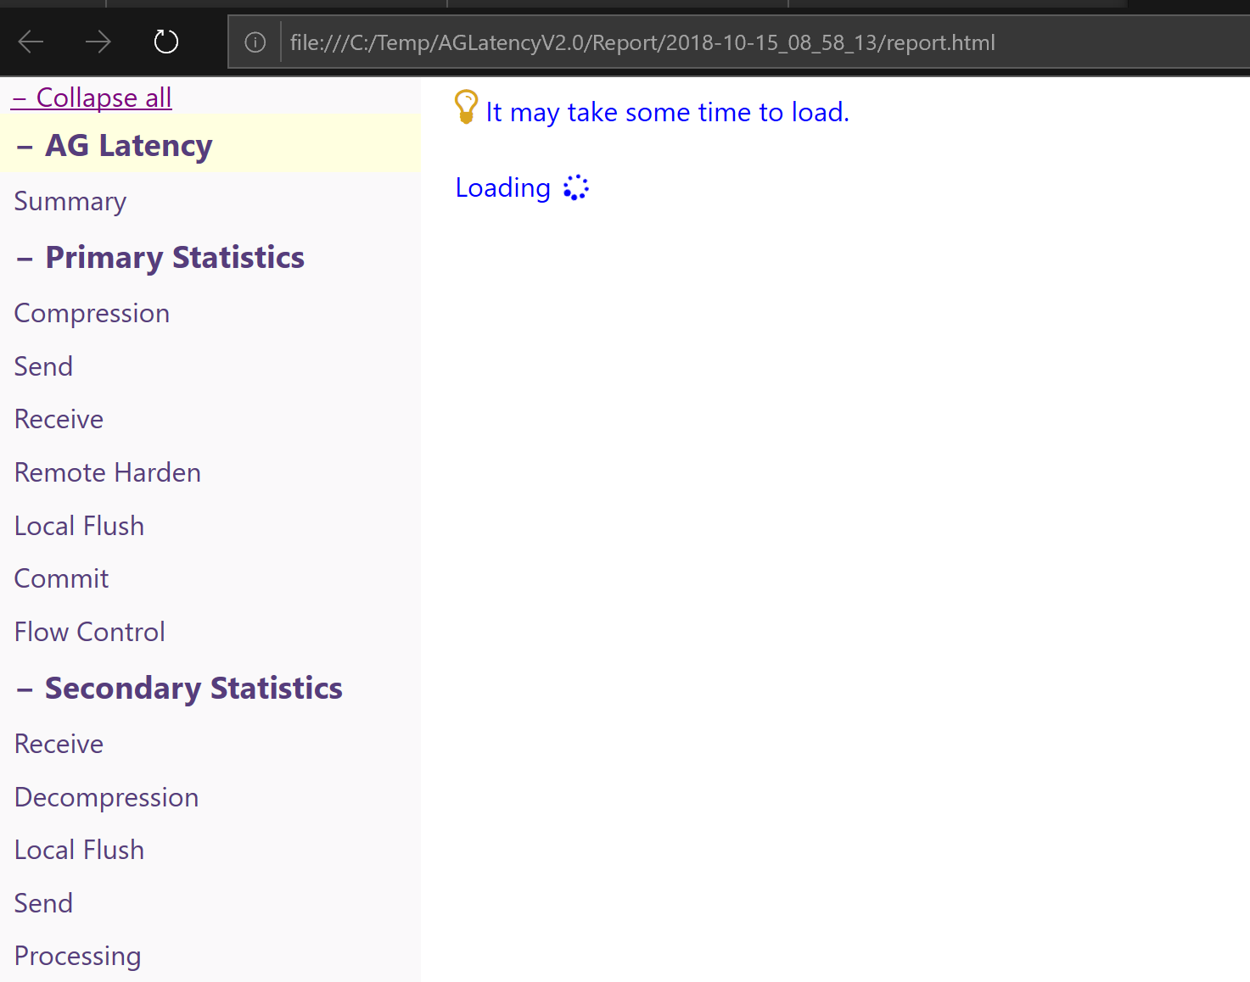

1. Report analysis

This section describes various sections of the output report.



## Reference chart

The diagram below depicts the end-to-end process for moving log blocks between the primary and secondary replicas in a synchronous commit availability group. The numbers on the diagram below correspond to the various data points throughout the report sections outlined below.

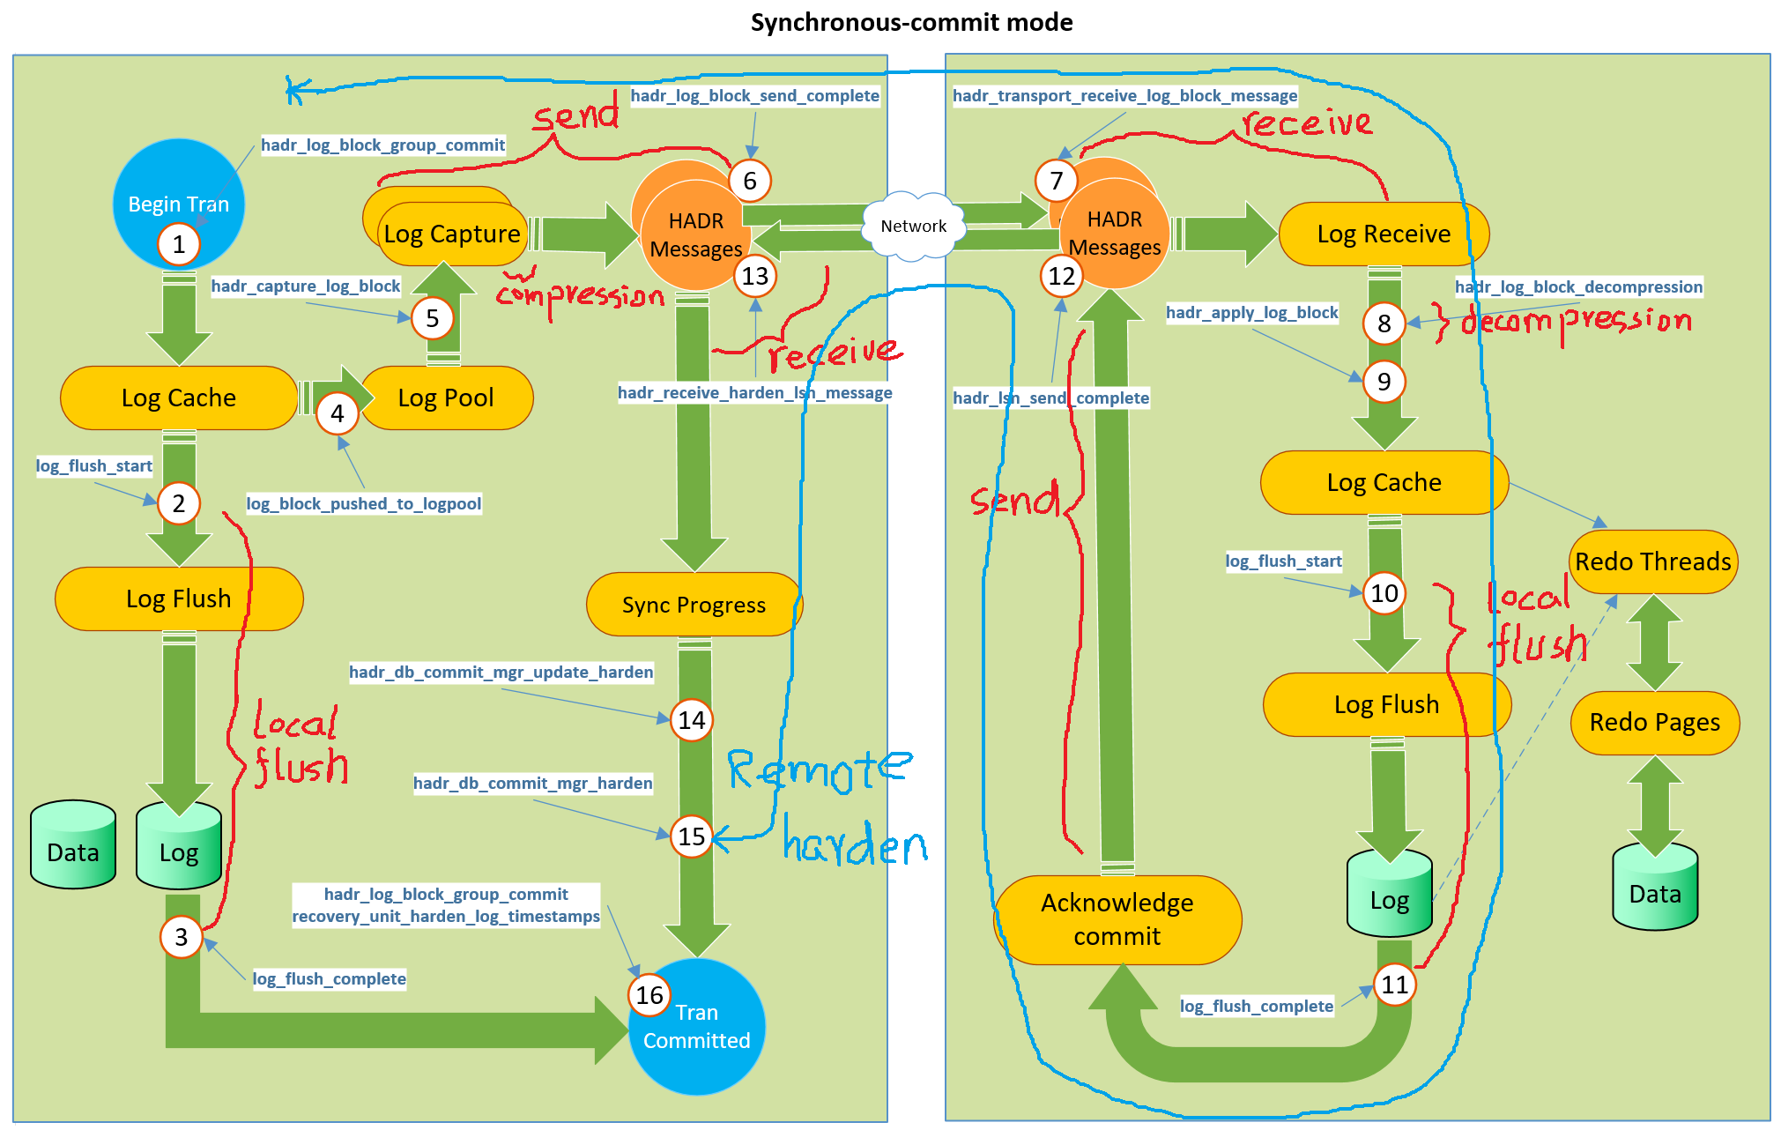

## Main screen

The main report screen will appear in a browser window at the completion of the trace file analysis detailed in section #4.

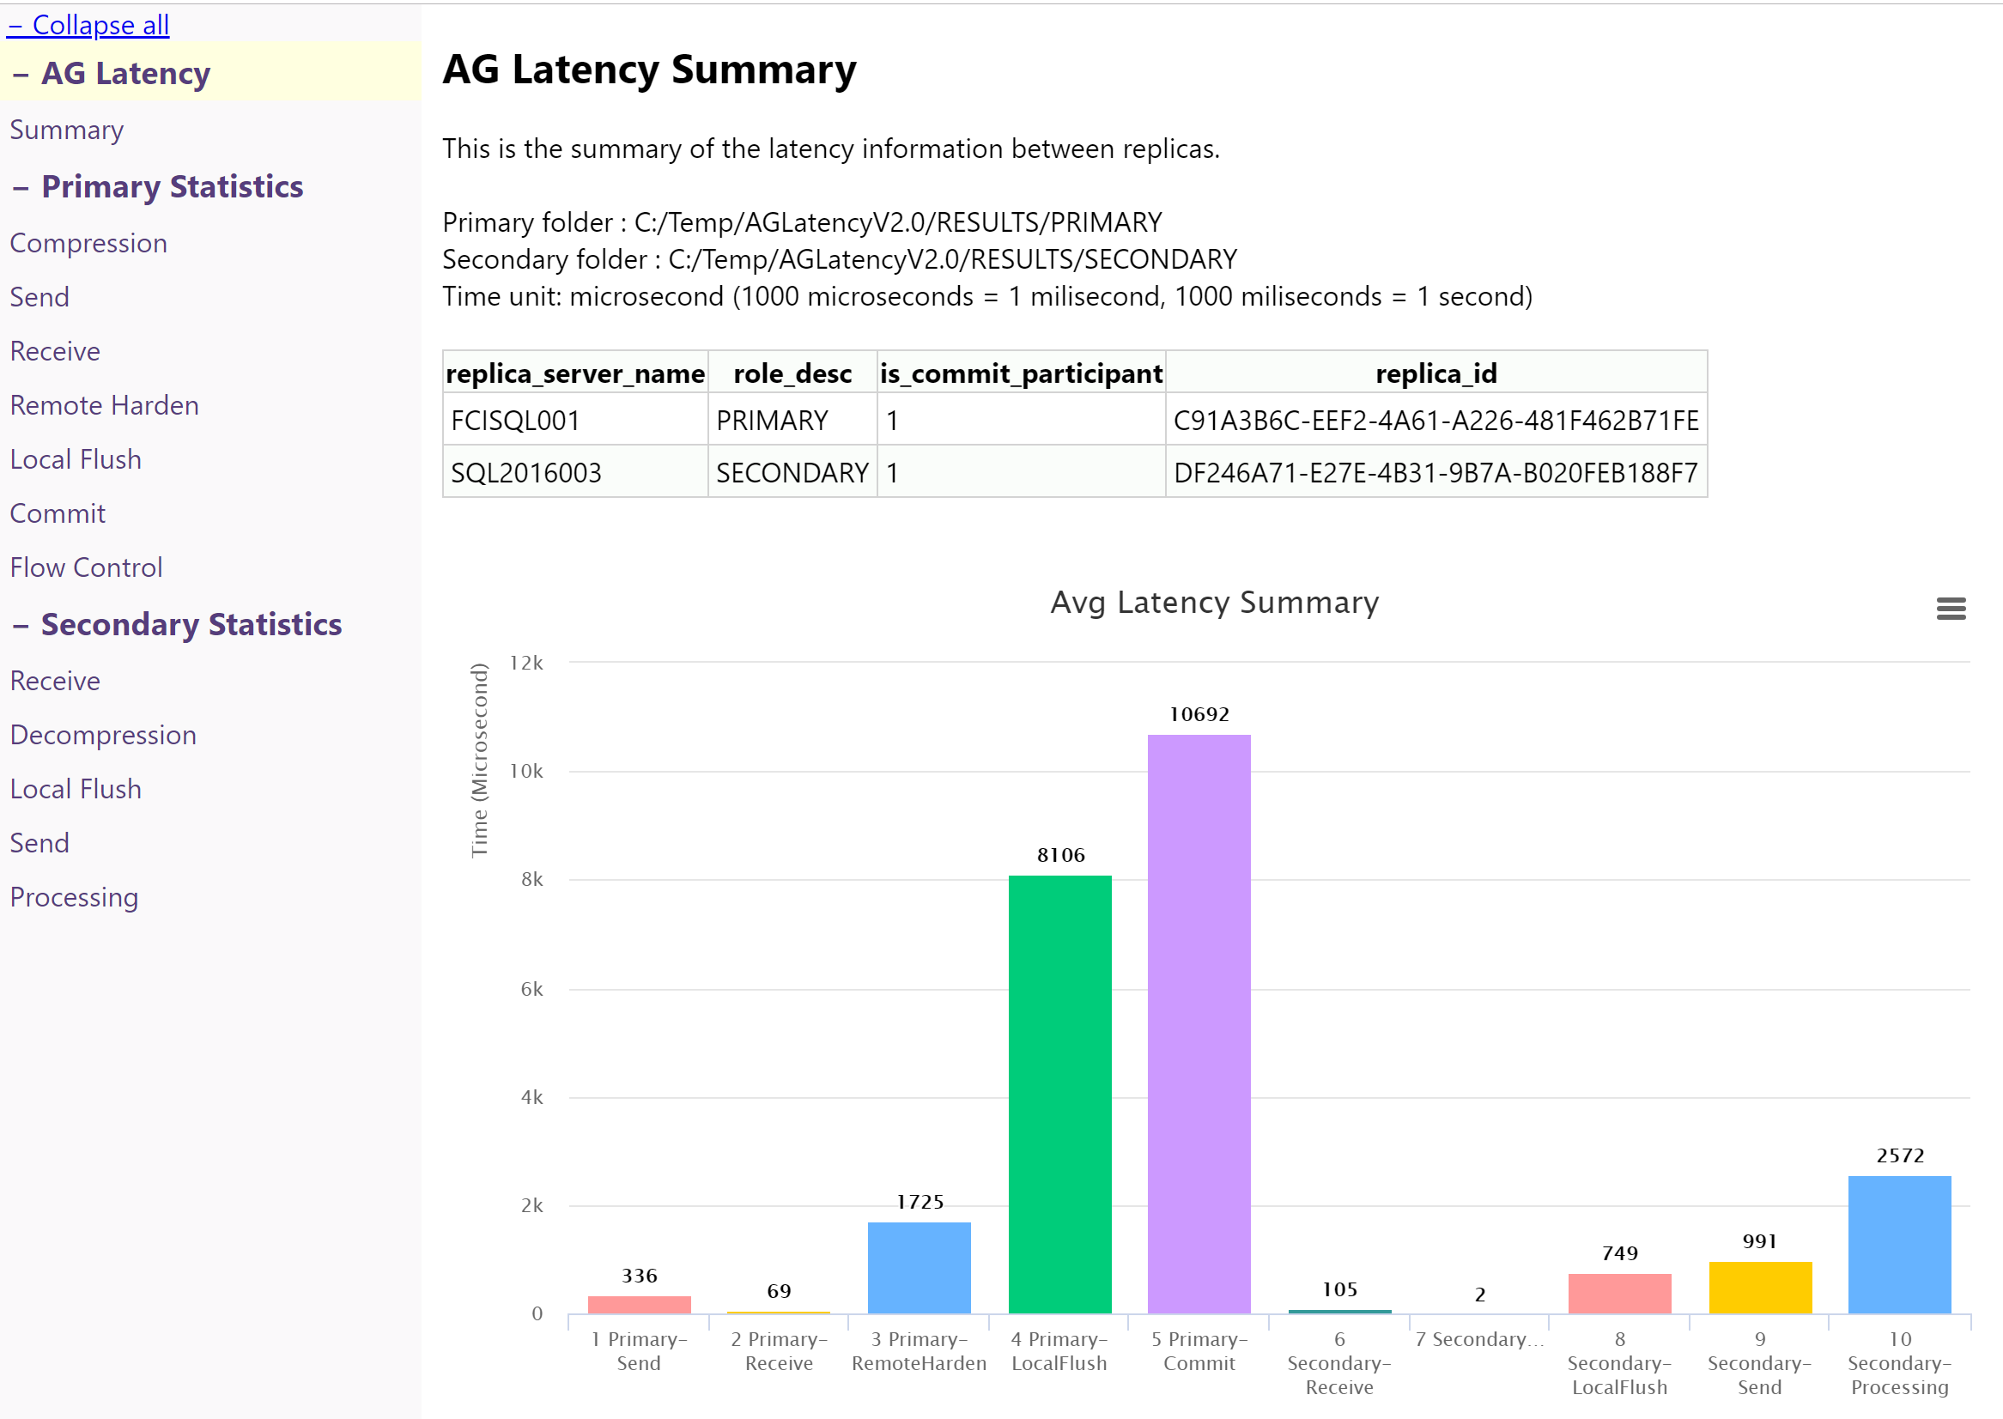

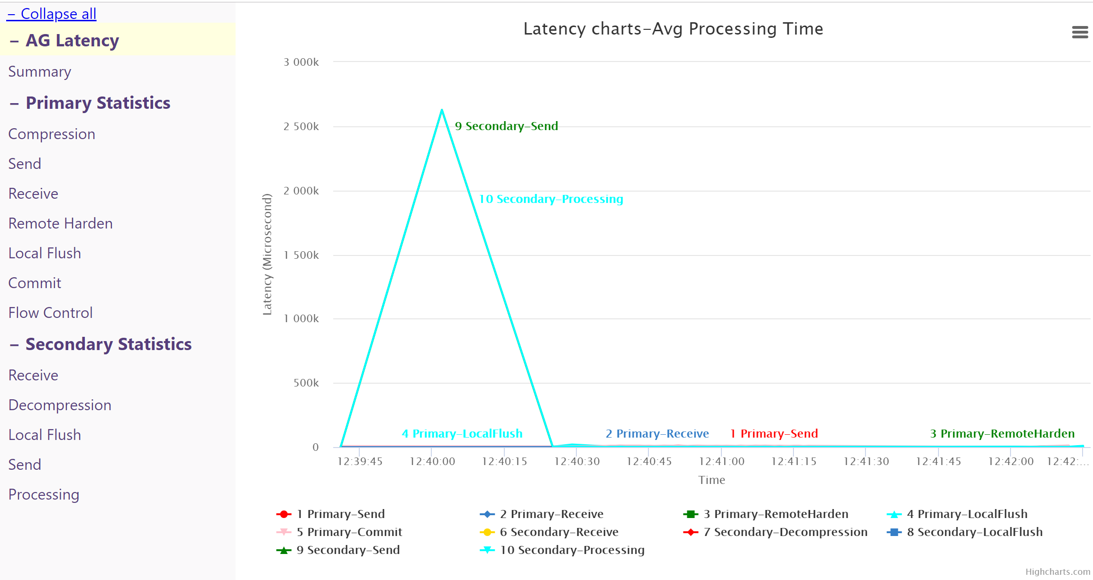

The charts and graphs are interactive and drilldown on a specific data point is possible by clicking and dragging on the desired data point.

The example below depicts closer inspection on the period between 1239 and 1240.

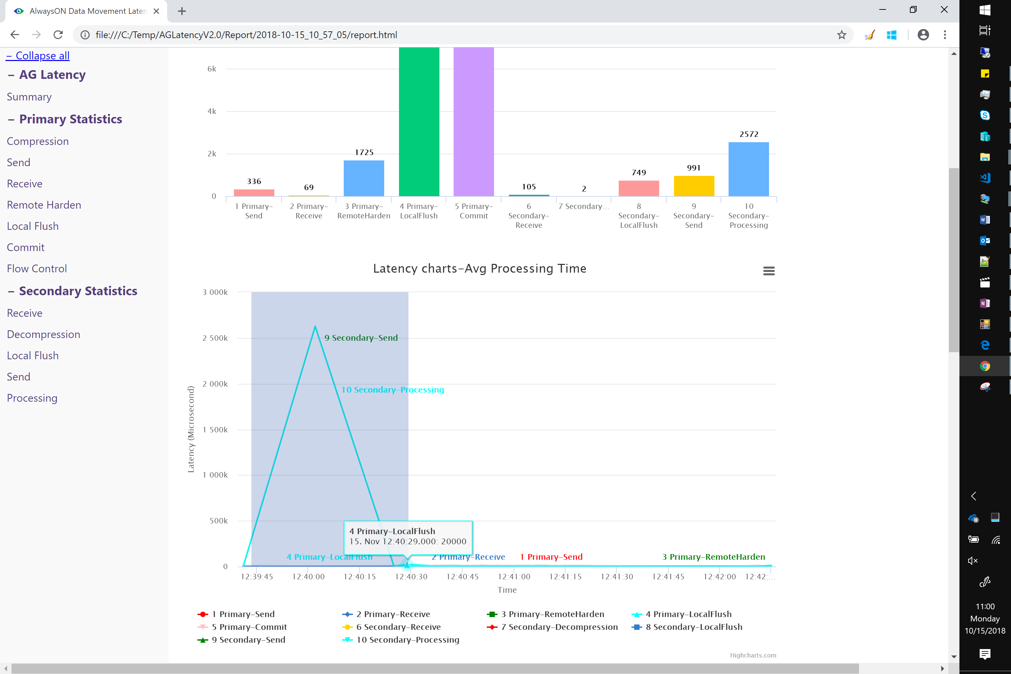

Charts can also be exported to several different image formats. Printing is also available.

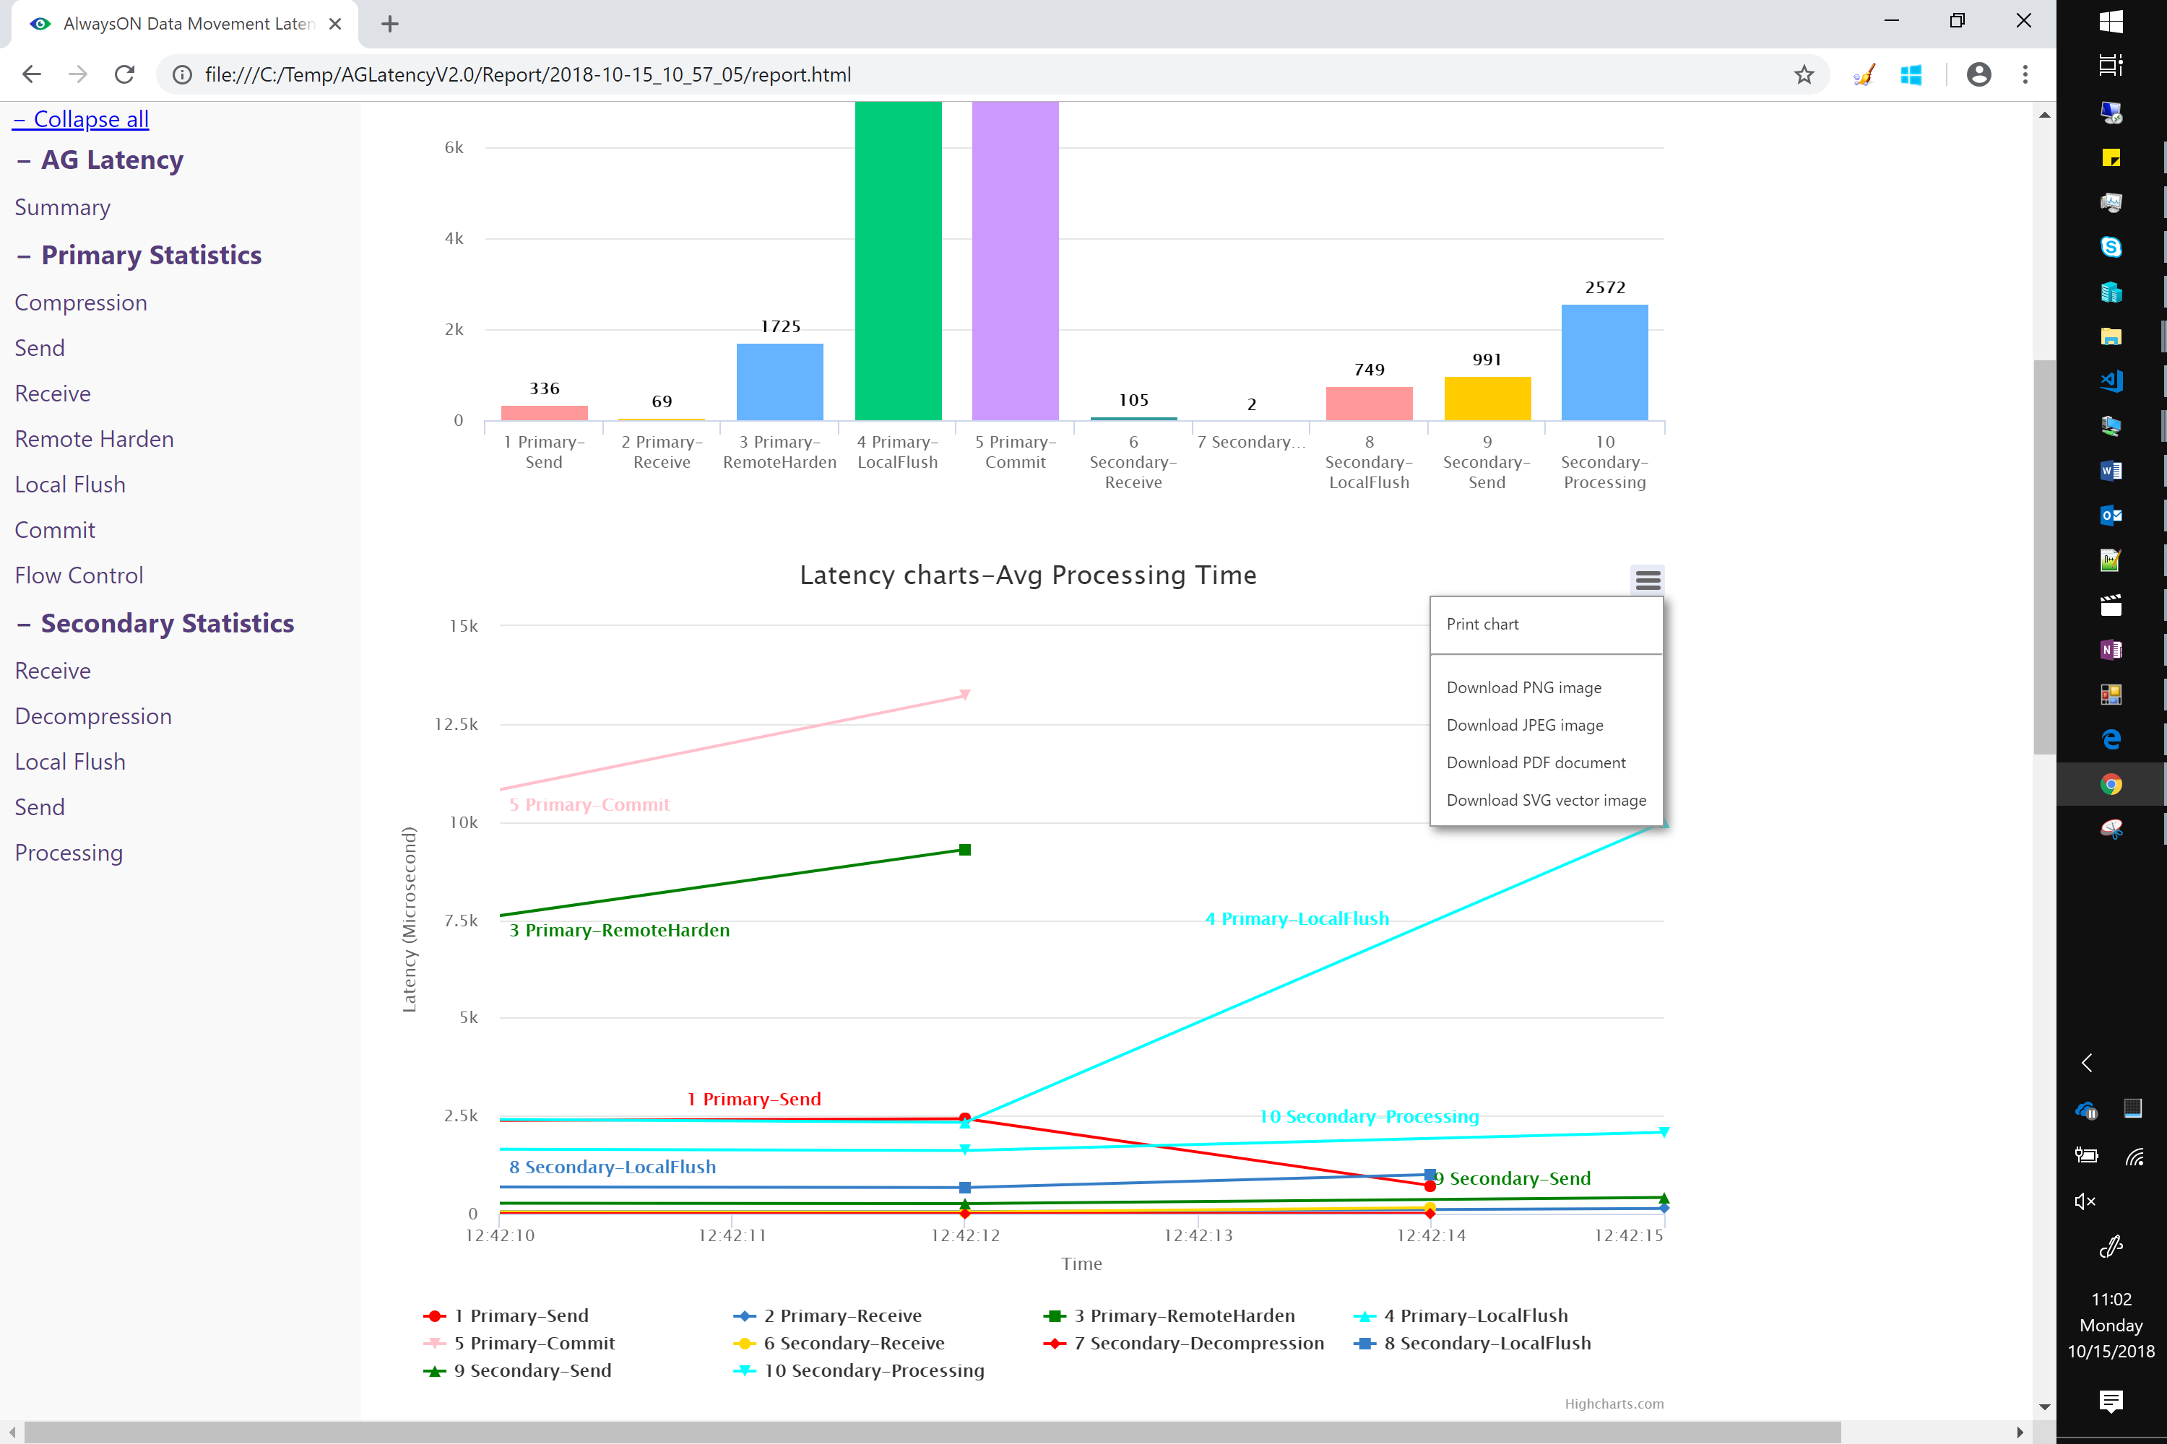

## Primary Statistics section

The Primary Statistics section of the report details statistics for the various stages of log block movement as it relates to the Primary replica.

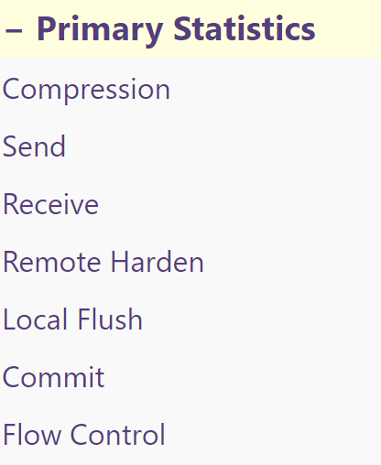

1. The Compression Statistics page will display time spent compressing log blocks on the primary replica.

**NOTE:** For SQL Server 2016 and above, if the Primary and Secondary replicas are a synchronous Availability Group, no compression statistics data will appear as log stream compression is not enabled by default.

AlwaysOn Availability Group log stream compression behavior can be controlled via trace flags [detailed in this article](https://docs.microsoft.com/en-us/sql/database-engine/availability-groups/windows/tune-compression-for-availability-group?view=sql-server-2017).

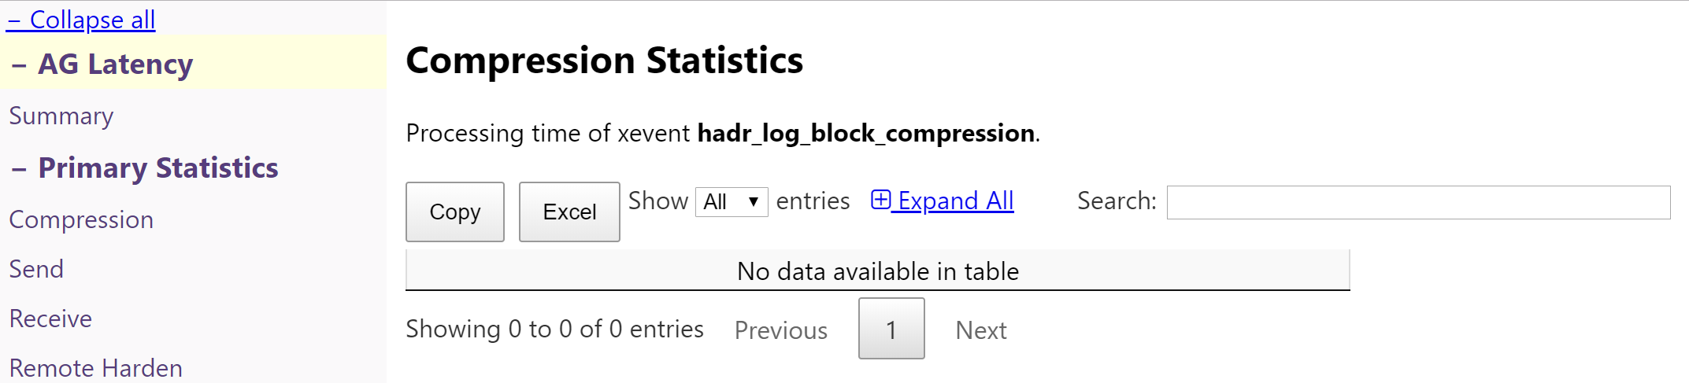

1. The Send Statistics page represents the amount of time spent sending log blocks to the UCS (Usage Control Service) layer in SQL. This corresponds to #6 on the diagram above. In synchronous replication, this does not include the time log blocks are traversing the network to the secondary replica.

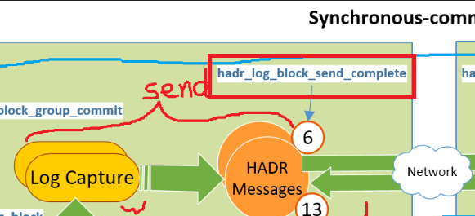

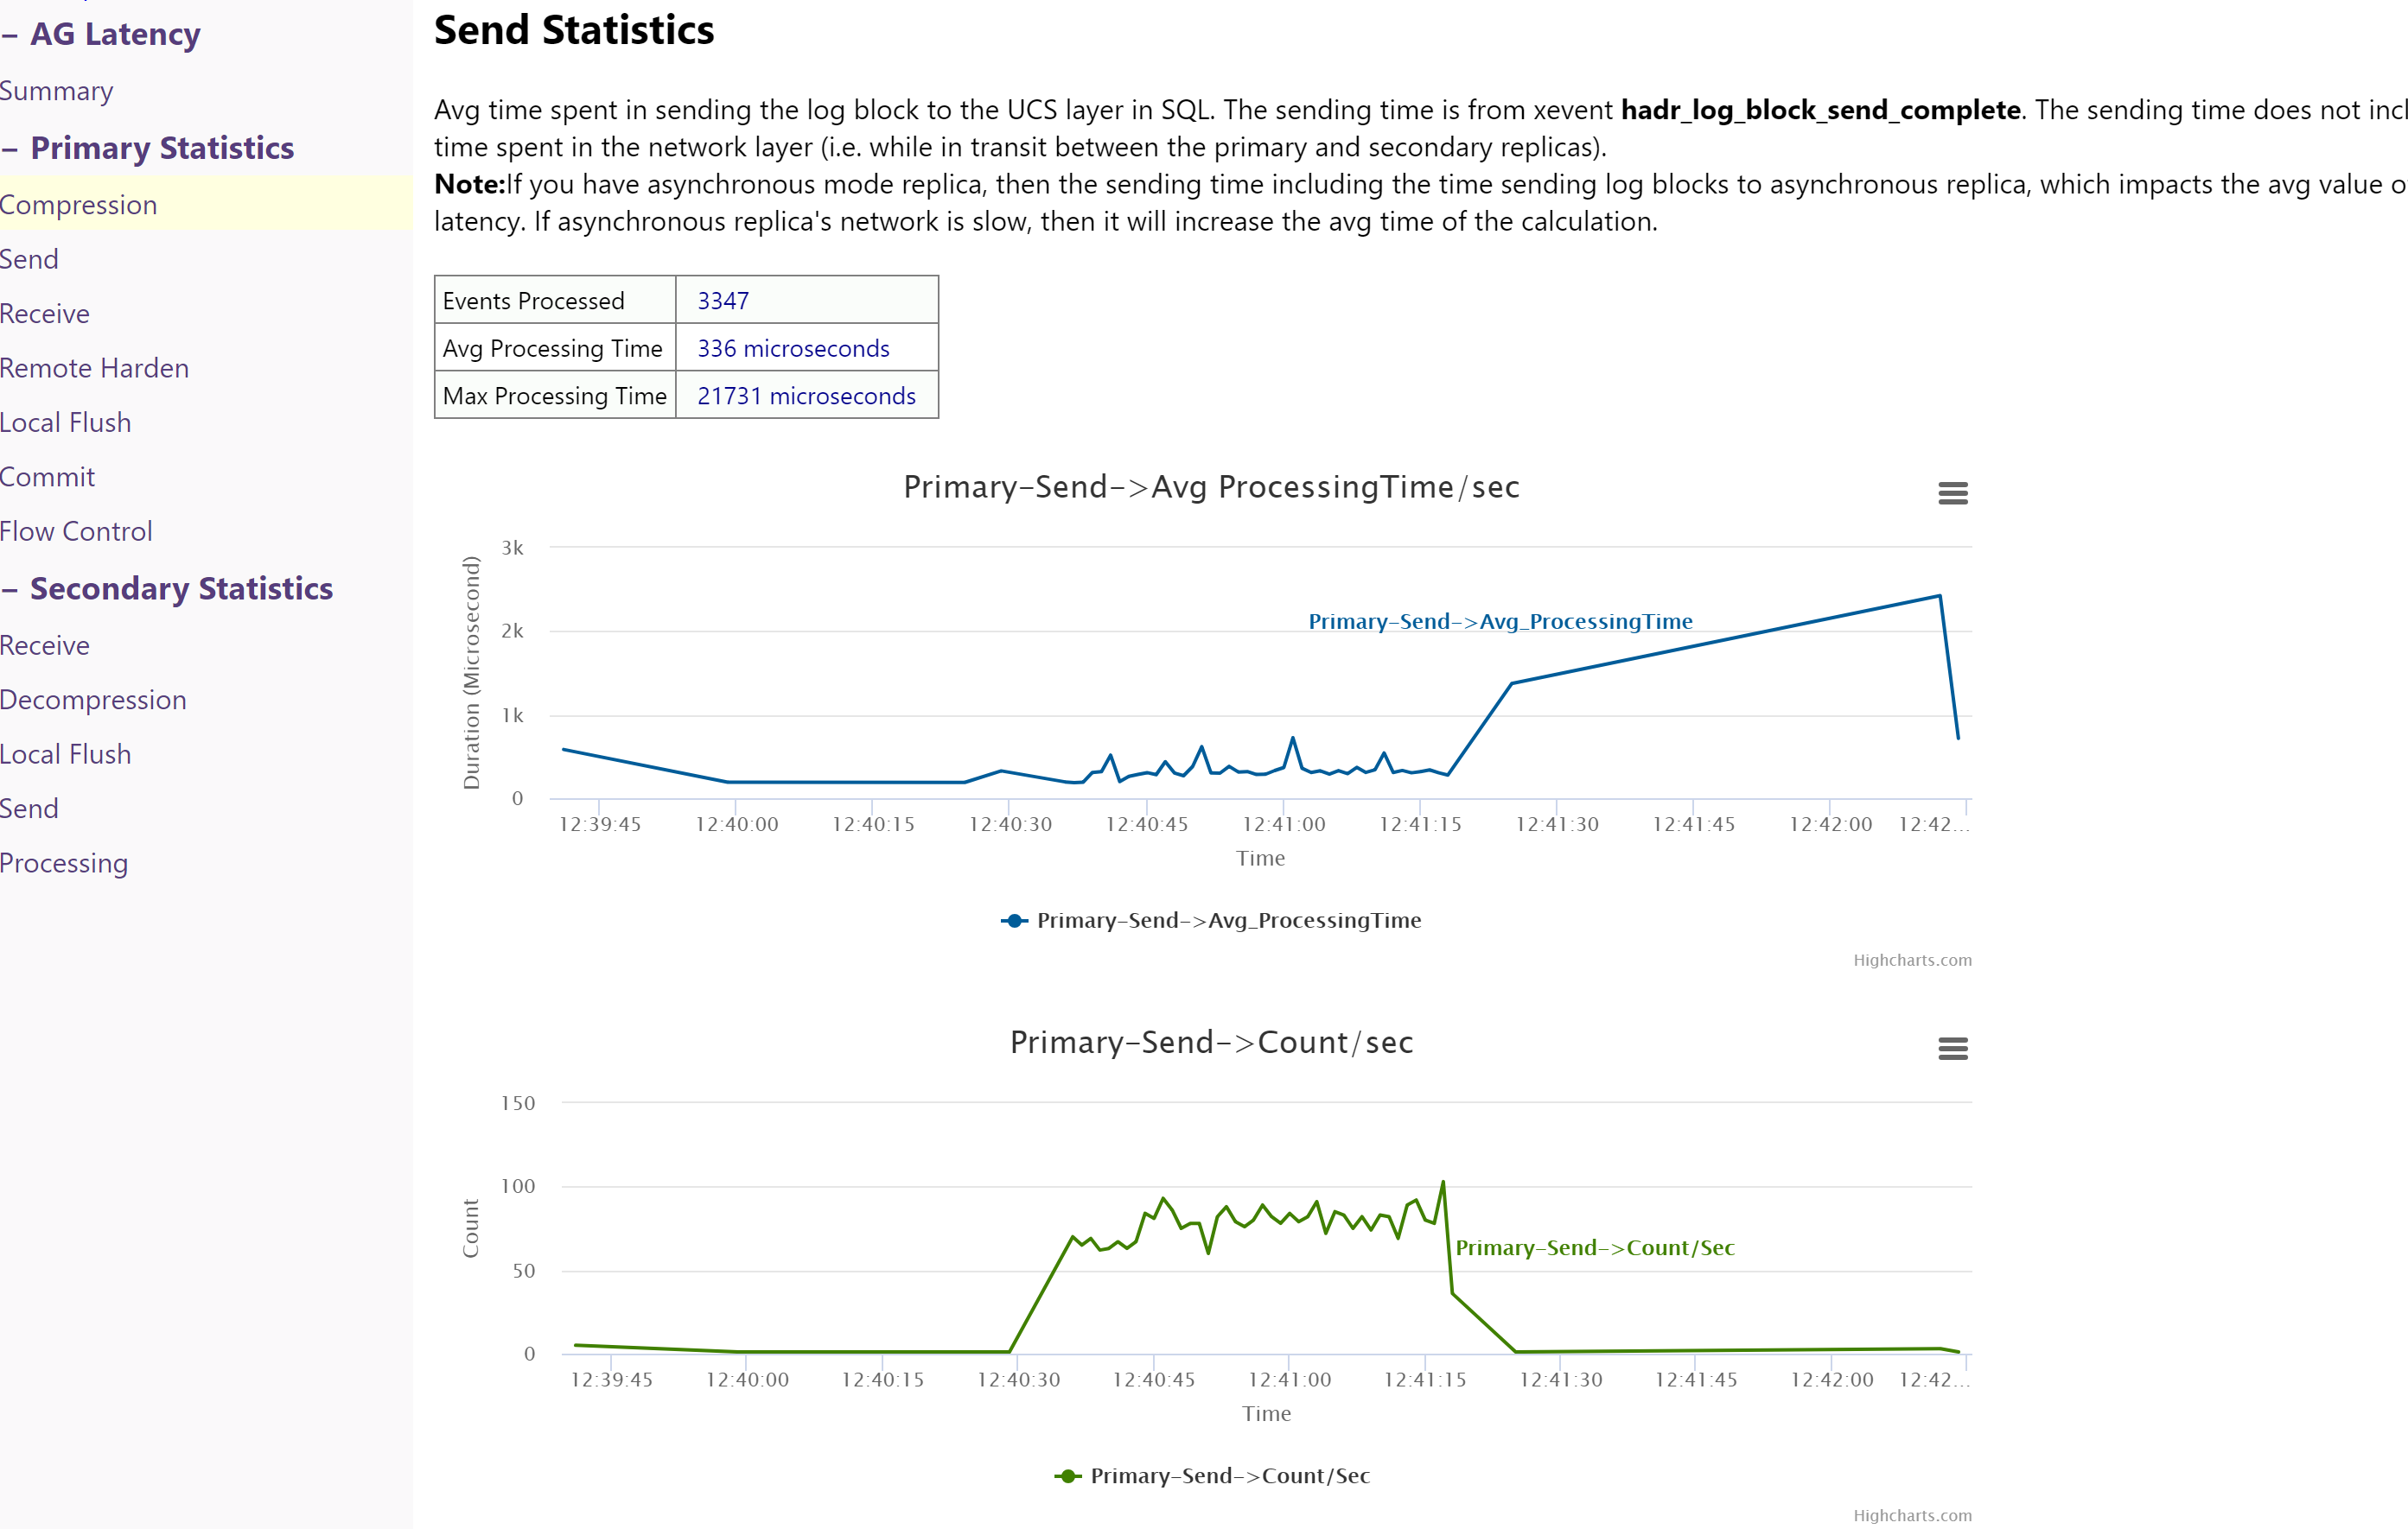

1. The Receive Statistics screen displays time spent receiving the hardened LSN message from the secondary replica.

This doesn’t include the time that message transverses on the network. It is the time delta that the primary receives the LSN ack message from UCS layer and then the message

gets processed while “hadr_receive_harden_lsn_message” event is fired.

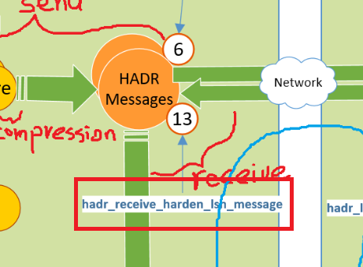

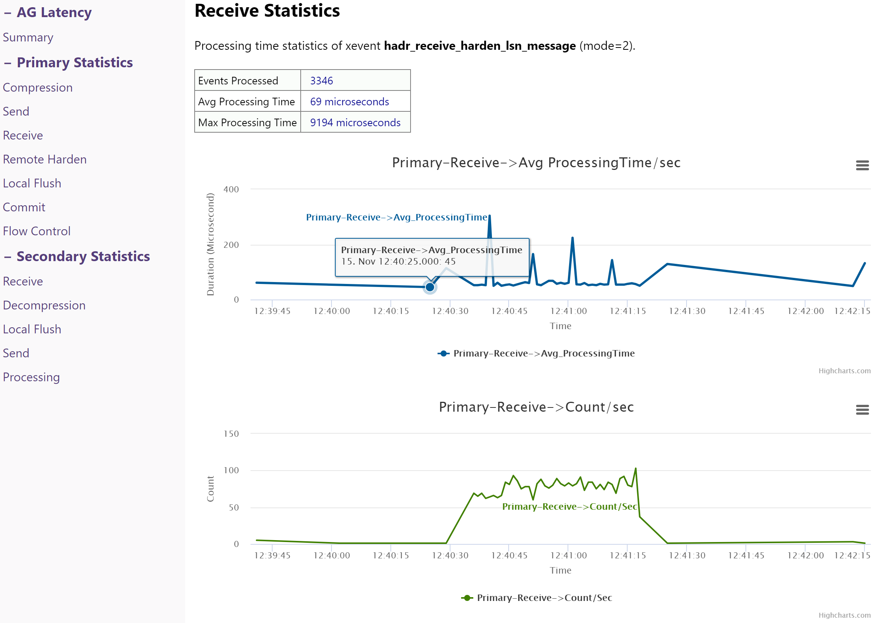

1. The Remote Harden Statistics displays the time spent sending log blocks to the secondary replica and receiving the associated LSN harden message back from the secondary replica.

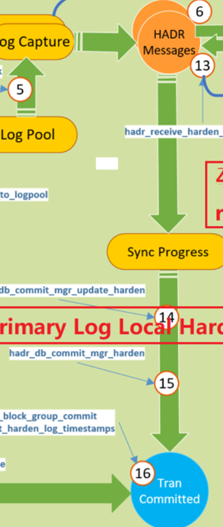

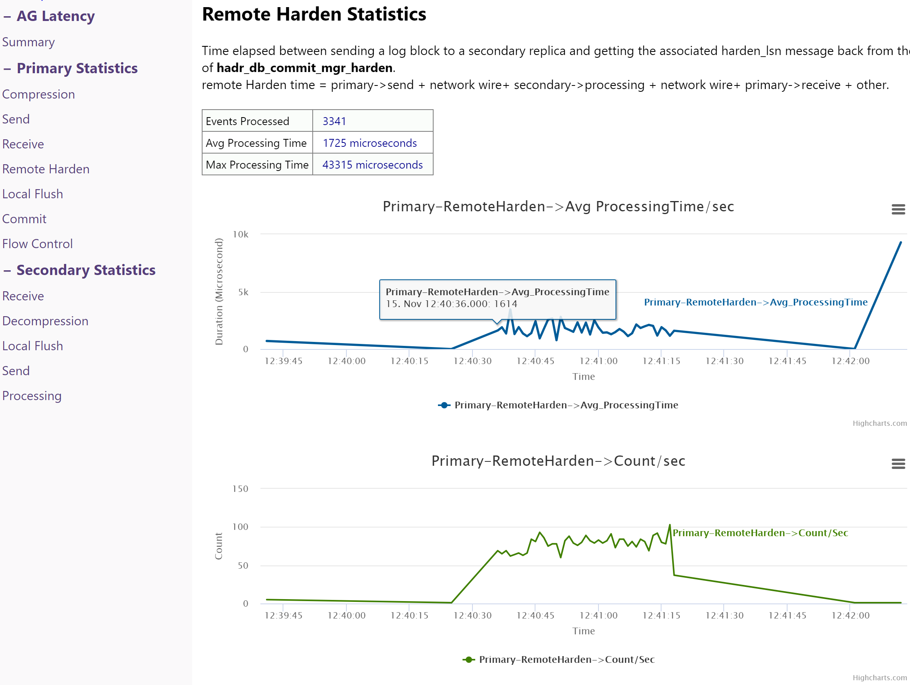

1. The Local Flush page displays time spent flushing log blocks to local media (disk).

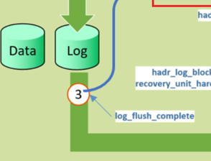

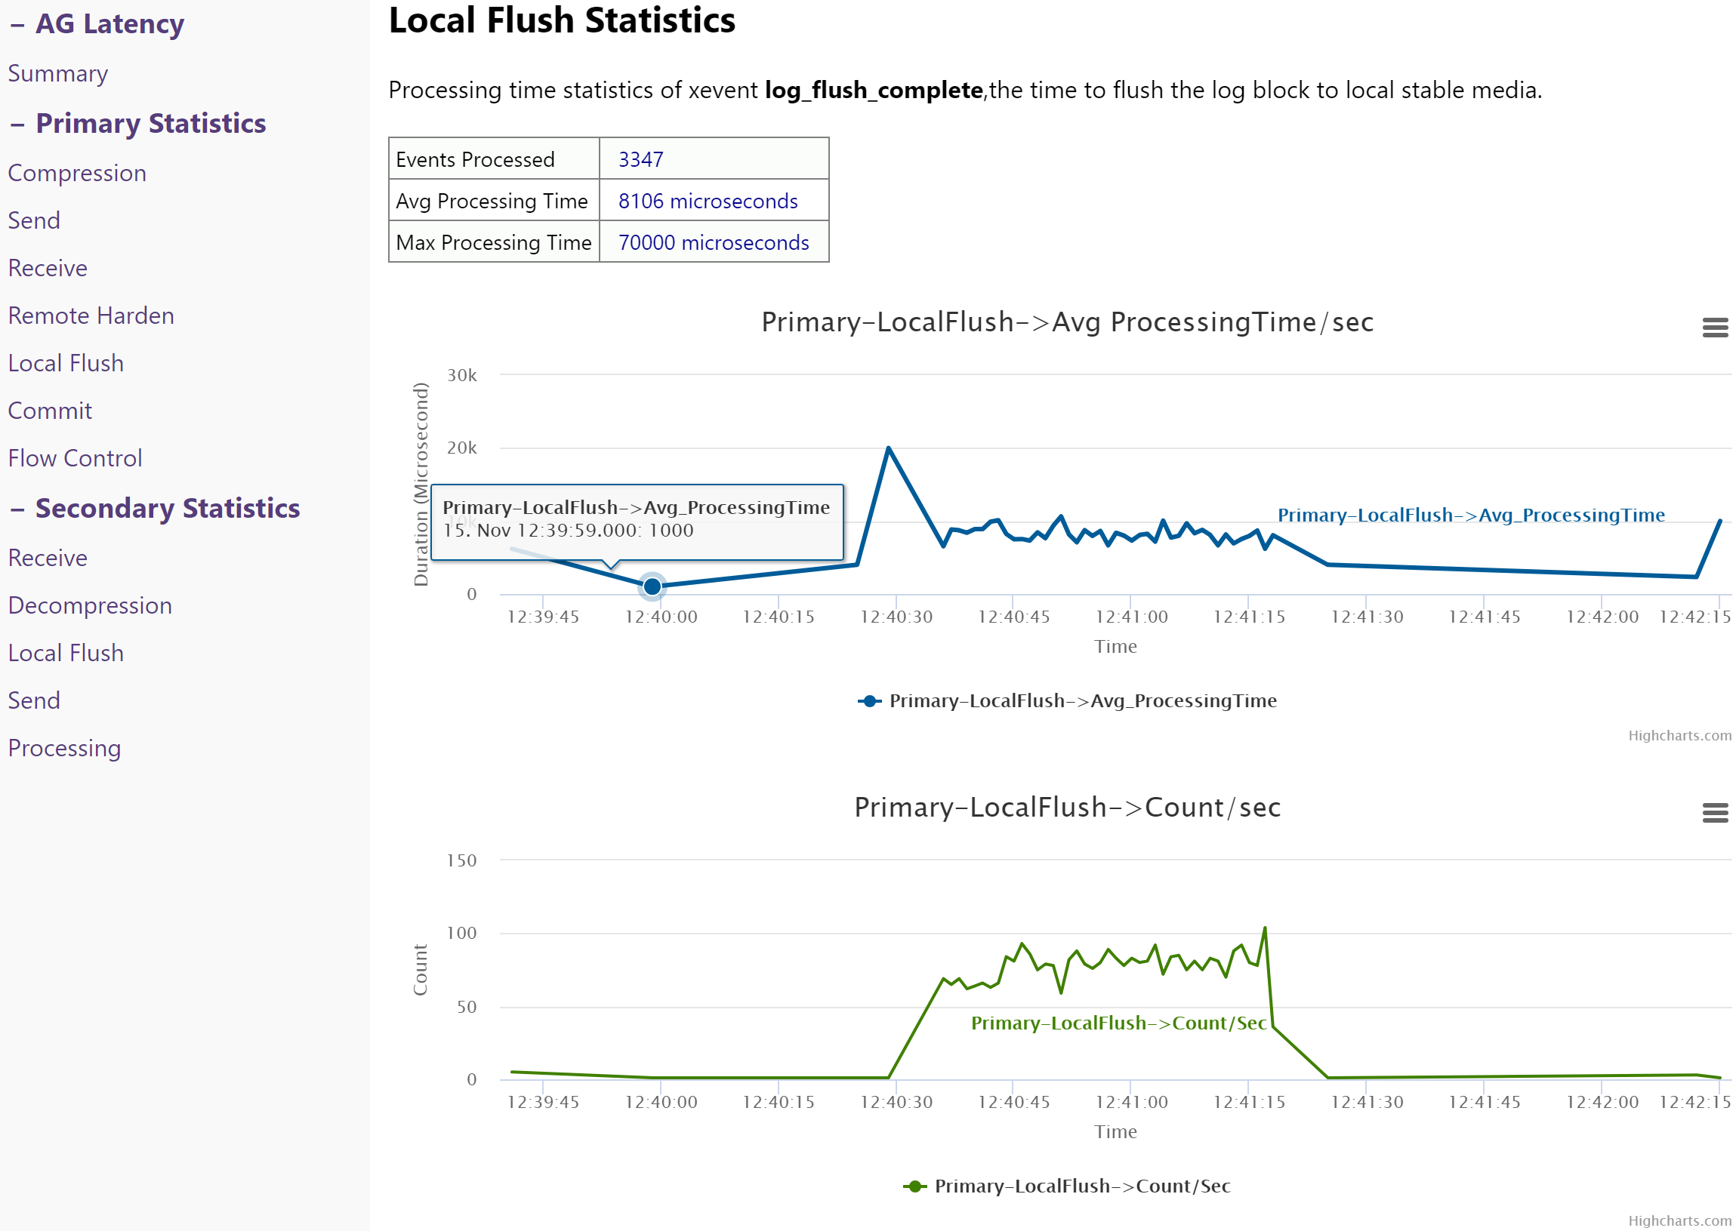

1. The Commit Statistics page displays the average time for transactions to commit on the Primary replica.

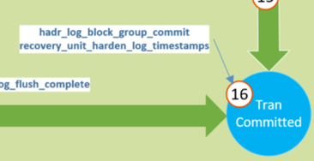

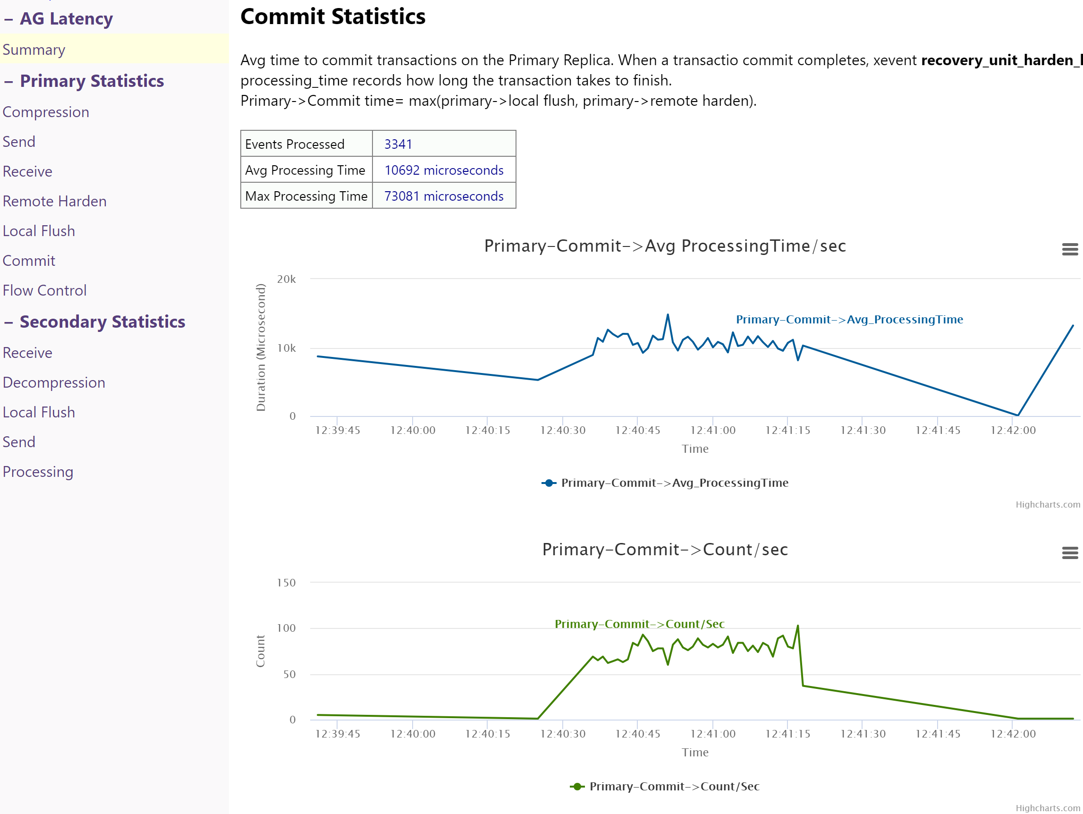

1. The Flow Control Statistics page displays time spent processing flow control actions. Flow control actions are set to either “0” or “1” (off and on) and indicates that there are messages waiting to be sent to secondary when the maximum number of queued messages has been reached.

This indicates that log scans are running faster than network sends. This indicates an issue only if network sends are slower than expected.

Database level flow control gate values (internally controlled) are:

* 1792 for x64 environments
* 256 for x86 environments

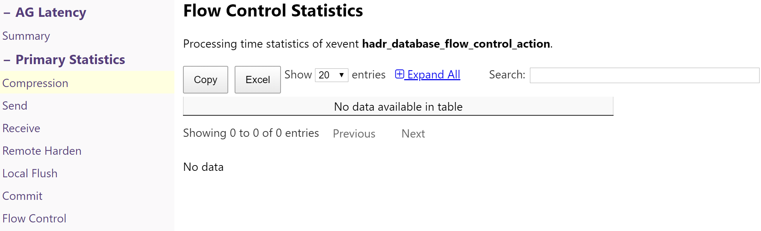

## Secondary Statistics section

The Secondary Statistics section of the report details statistics for the various stages of log block movement as it relates to the Secondary replica.

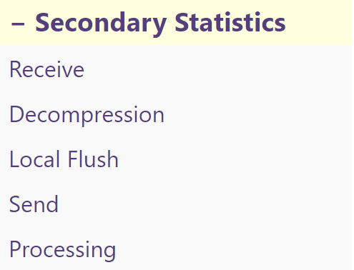

1. The Receive Statistics page details time spent processing receipt of log blocks on the Secondary replica.

This doesn’t include the time it spends on the network. The time duration begins when secondary UCS receives the message and ends when the xevent “hardr_transport_receive_log_block_message” is fired.

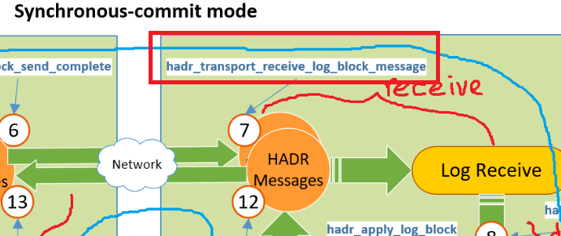

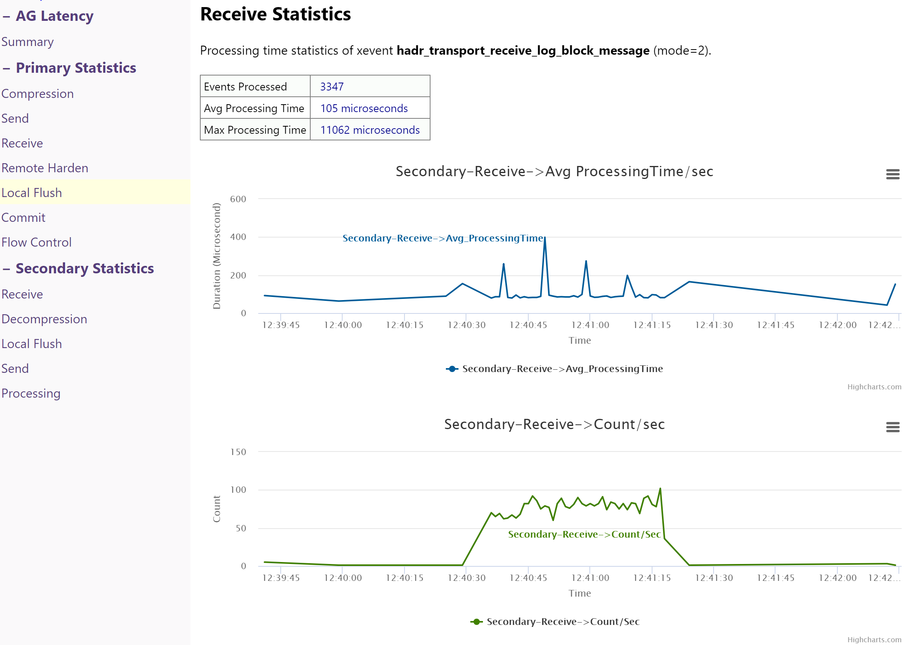

1. The Decompression Statistics page details time spent decompression log blocks on the Secondary replica.

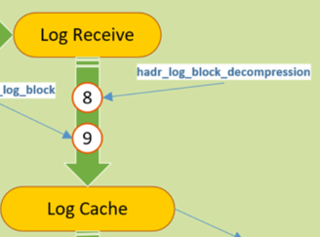

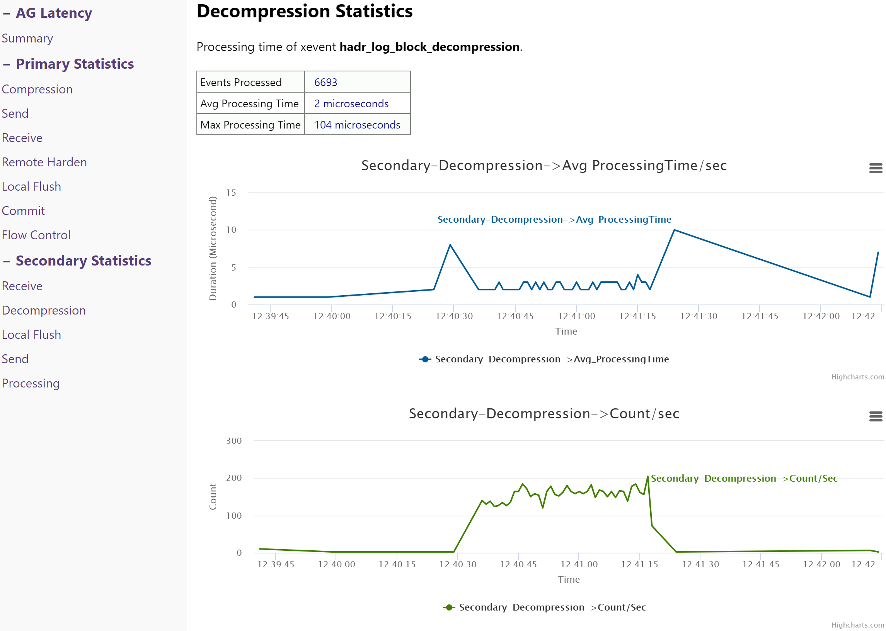

1. The Local Flush statistics page details the time spent flushing log blocks to local media (disk) on the Secondary replica.

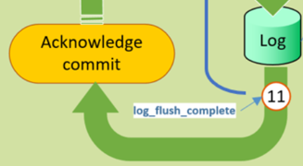

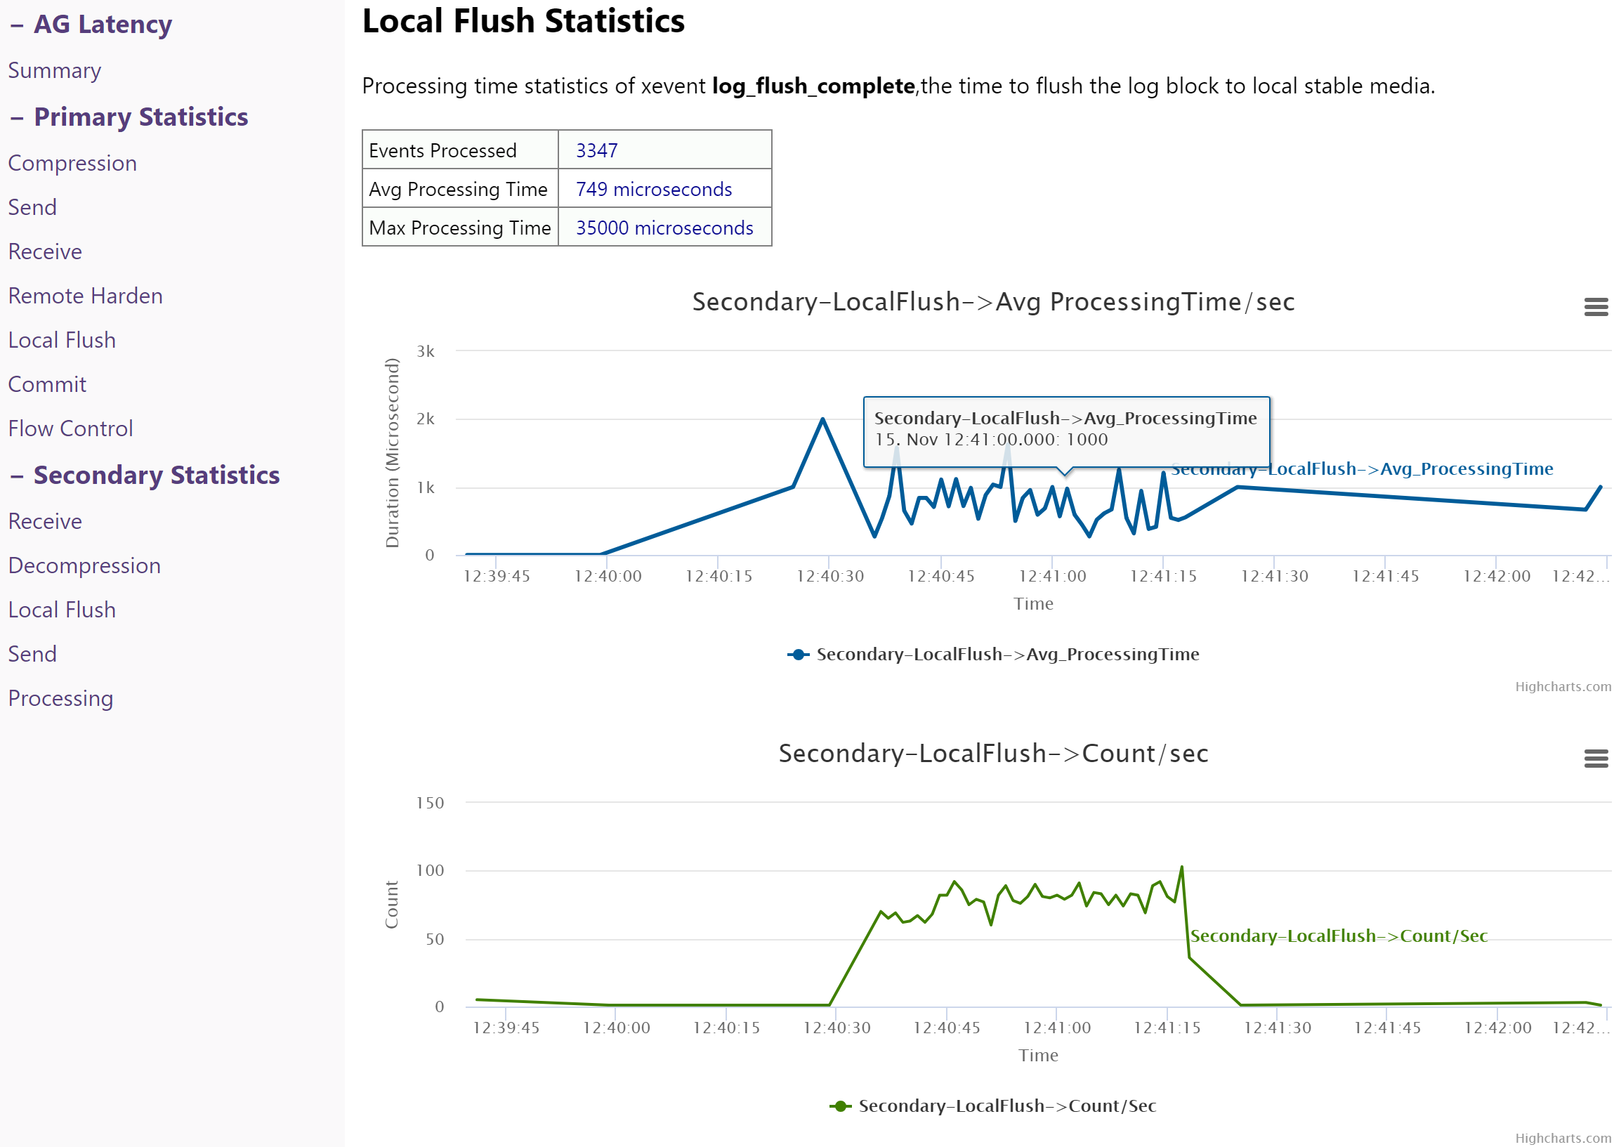

1. The Send Statistics page displays time spent process LSN send complete messages.

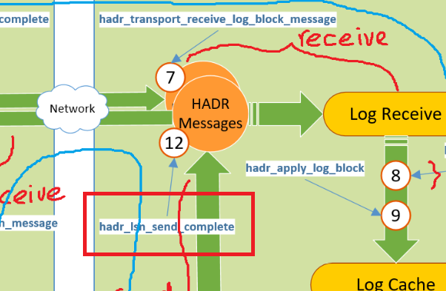

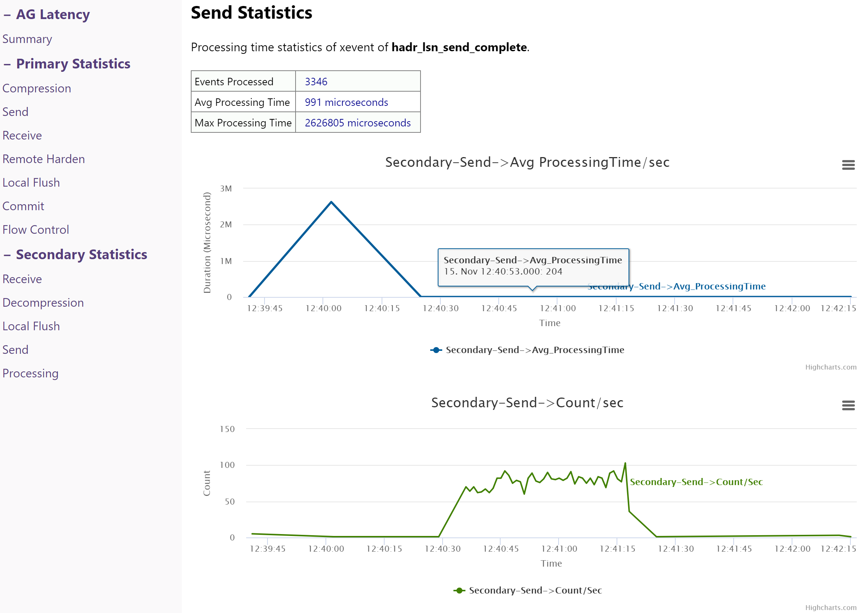

1. The Processing Statistics page indicates the average total processing time of log blocks on the Secondary replica.



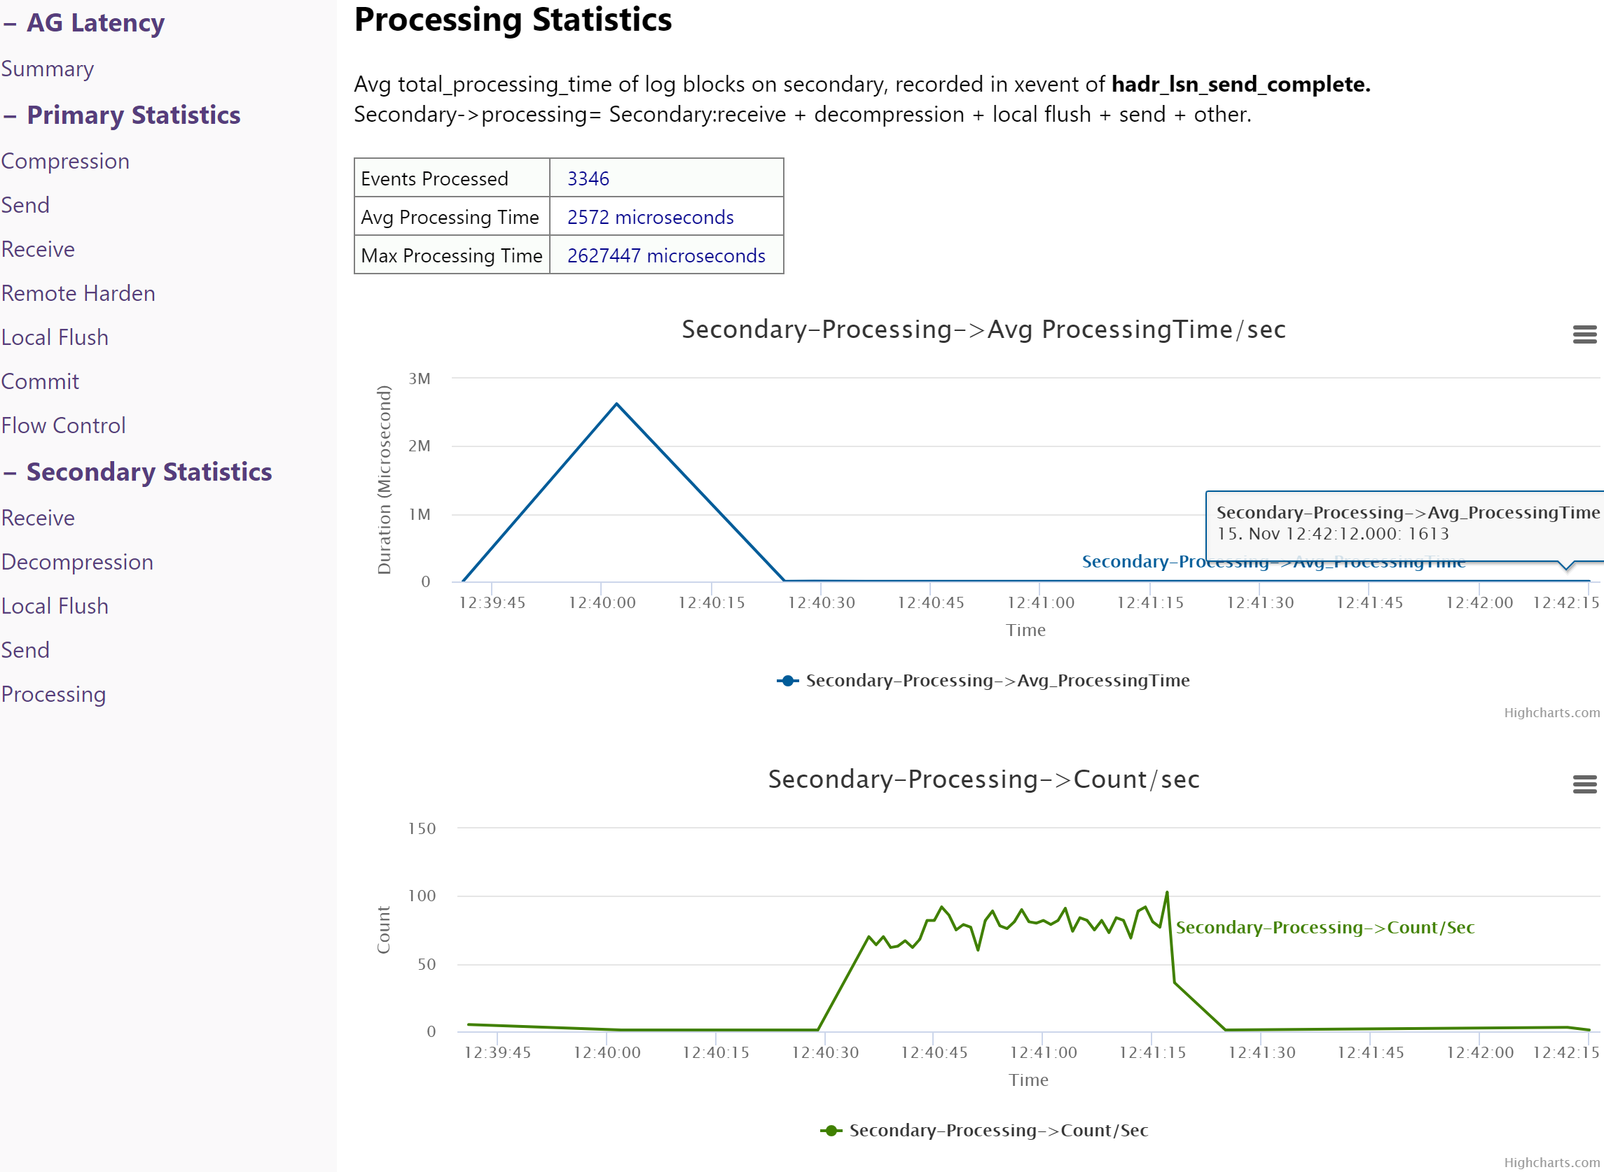

1. Miscellaneous

## Historical reports

Each time a new set of extended event session files is analyzed and corresponding reports generated, a new directory with the date and time as directory name will be created in the “…\AGLatencyV2.0\Report” directory.

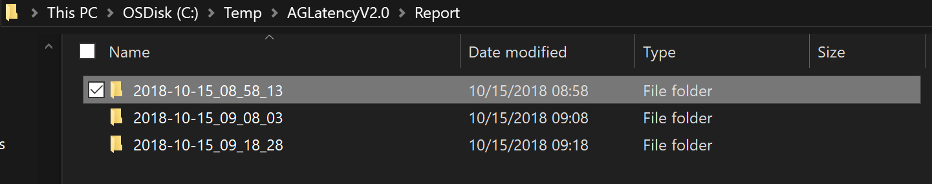

1. References

<https://blogs.msdn.microsoft.com/psssql/2018/04/05/troubleshooting-data-movement-latency-between-synchronous-commit-always-on-availability-groups/>

<https://github.com/suyouquan/AGLatency>